IGCSE Chemistry

Separate Award

Revision Guide

Topic Page
3rd year chemistry 1-6
Atomic Structure 7-8
Structure and Bonding – Ionic Bonding 9-10
Structure and Bonding – Covalent and Metallic Bonding 11-14
Organic Chemistry - Alkanes 14-17
Organic Chemistry – Alkenes / Addition Polymerisation 18-19
Organic Chemistry – Alcohols / Condensation Polymerisation 20-22
Calculations 23-32
Periodic Table 33-39
Reactivity Series and Metal Extraction 40-44
Electrolysis 45-48
Energetics 49-51
Acids, Bases, Salts and Neutralisation 52-58
Preparing and Analysing Salts 59-63
Rates 64-65
Equilibria and the Haber Process 66-70

© Dr C. R. Lawrence
States of matter
SOLIDS: (particles in contact; attractions hold them in fixed positions)
- have definite shape and volume
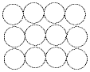

LIQUIDS: (particles in contact, and attract each other, but are free to move around)
- have a definite volume
- they take the shape of a container
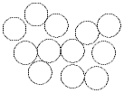

GASES: (particles widely separated; little or no attraction; move freely until they collide)
- spread out (diffuse) and into all the space that is available and will mix completely with any other gas(es) in the same space
- are compressible (i.e. can be squashed up into a smaller volume)
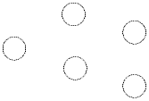

The following diagram shows the names given to the various changes of state.
Sublimation

Evaporation (at
any temperature)

Melting
(at fixed temp = m.p.t)

Boiling
(at fixed temp = b.p.t)

SOLID
LIQUID
GAS/VAPOUR

Freezing
(at fixed temp = m.p.t)
Condensation
(at fixed temp = b.p.t)

Sublimation

When substances change state, energy is involved.
Change of State | Energy Change | Reason for energy change
Solid → Liquid | Heat taken in | Energy needed to break bonds between the particles in the solid
Liquid → Gas | Heat taken in | Energy needed to break the forces between the particles in the liquid
Liquid → Solid | Heat given out | Energy given out as particles bond together in the solid
Gas → Liquid | Heat given out | Energy given out as particles bond together in the liquid
Kinetic Theory
The properties of solids, liquids and gases can be explained by kinetic theory.
Kinetic theory states that matter is made of tiny particles that move all the time.
The main points of the theory are;
- All matter is made of tiny, invisible, moving particles.
- The particles move all the time. The higher the temperature the faster they move.
- Heavier particles move more slowly than light ones at a given temperature.

DIFFUSION: this is the mixing of atoms or molecules due to their continuous and random motion. e.g. Mixing of bromine vapour and air.

BROWNIAN MOTION: the constant random movement of tiny particles (e.g. smoke particles, or pollen on a drop of water) is caused by collision with (invisible) air or water molecules, which are themselves in continuous and random motion. e.g.
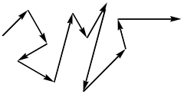
Experiments using gases diffusing in a tube are used to examine the motion of the particles.
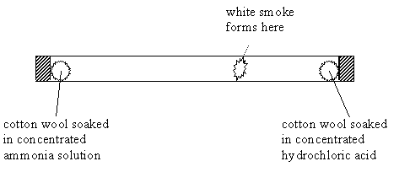
Ammonia and hydrochloric acid particles under Brownian motion as they hit air particles in the tube.
When they meet white smoke (ammonium chloride) forms.
As the ammonia travels farthest along the tube we know that;
- The ammonia particles move faster than hydrochloric acid particles.
- The ammonia particles are lighter than the hydrochloric acid particles.

Heating and Cooling Curves
We can use kinetic theory to explain changes in state when substances are heated or cooled.

D
Temp

B
C

A
time (steady heating)

- In a solid the particles are held in position by bonding to their neighbours.
(A on the graph).
- As the solid is warmed the particles vibrate but cannot move.
(Between A and B on the graph).
- When heated enough the particles vibrate so much that they can tear themselves free from their positions, and the substance melts to a liquid.
- At the melting point heat needs to be added to melt the solid and break the bonds between the particles, so the temperature doesn’t rise until it is all liquid.
(Between B and C on the graph).
- As the liquid is heated up the particles gain energy.
(Between C and D on the graph).
- At the boiling point heat needs to be added to change break the forces between the particles in the liquid turning the substance into a gas.

Elements, Mixtures and Compounds

THE ATOMIC THEORY
This theory assumes that all elements are made up of "atoms". If you were to divide a lump of an element into smaller and smaller pieces you would eventually come to a piece that could not be divided any further - a single ATOM of the element. Atoms are therefore very small. We can see this if we dilute a solution of potassium manganate(VI) many times. It is still coloured even when it is very dilute.

Definition: An atom is the smallest particle of an element that can exist or take part in a chemical change.

MOLECULES
All elements are made up of atoms. In some gaseous elements (e.g. argon) single atoms move around freely. But in other gaseous elements, single atoms cannot exist on their own at ordinary temperatures: in these elements the free-moving particles consist of pairs of atoms.
The two atoms forming a pair (a MOLECULE) are joined together by a chemical "bond". This is the case with hydrogen (H2), oxygen (O2) and nitrogen (N2). Such substances are said to be diatomic.
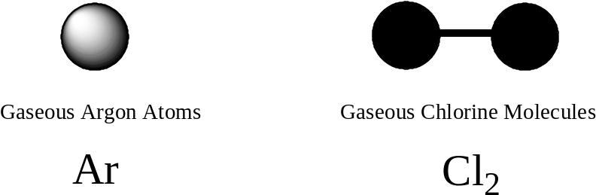

An ELEMENT is a pure substance made up of only one type of ATOM.

A COMPOUND is a pure substance which contains two or more elements, chemically bonded together in a fixed proportion.

A MIXTURE is a group of substances that are not chemically bonded together.

Compounds Mixtures
Proportions of elements are fixed. Proportions may vary.

Properties different from those Properties are simply those of
of the elements. the separate elements.

Cannot be separated into elements Can be separated by a physical
without chemical reaction. change (e.g. dissolving one
of the elements)

There is usually an energy change No energy change when the
when a compound is made from elements are mixed.
its elements.
Separation Techniques

1. SOLID & LIQUID
(a) If the solid has not dissolved in the liquid (i.e. is suspended in the liquid), the two substances can be separated by FILTRATION.
The liquid filtrate passes through, the undissolved solid residue stays on the paper.

(b) If the solid has dissolved in the liquid, forming a solution:-
(i) If only the solid is required, it is obtained by EVAPORATION.
(ii) If the liquid is required, it is obtained by DISTILLATION. The solution is placed in a flask and heated. The liquid evasporates, and its vapour passes into a condenser, where it cools and turns back to liquid. (The solid remains behind in the flask as a residue).
Note – The thermometer bulb should be at the level of the condenser.

2. LIQUID & LIQUID
(a) Immiscible liquids - by using a SEPARATING FUNNEL
When two liquids do not mix (e.g. paraffin and water), they can be separated simply by
running off the denser liquid from a separating funnel by opening the tap.

(b) Miscible liquids - by FRACTIONAL DISTILLATION
Both liquids evaporate, and their vapours pass into a fractionating column, where they are condensed and re-boiled many times. The vapour of the liquid which has the lower boiling point. emerges from the top of the column first, and passes into the condenser.
When all of this liquid has distilled, it is followed by the liquid having the higher boiling point.

3. SOLID & SOLID Usually one of the following methods can be used:-

(a) DISSOLVING: Find a solvent that will dissolve one solid but not the other.
It is often necessary to heat in order to help the process of dissolving. Then filter, wash the residue on the filter-paper with a little of the solvent, and dry it. To obtain the second solid (now in solution, in the filtrate), evaporate the filtrate, as in 1(b)(i) above.

(b) CHROMATOGRAPHY: This is a method for separating two solids that are both soluble in the same solvent. Find a solvent that will dissolve both solids, make a solution of the mixture and place two drops of the solution on a piece of filter-paper.
Allow a suitable liquid to spread gradually across the paper.
The solid that is more soluble in the liquid will will move through the greatest distance, and the solid that is least soluble will move least.
Thus the dissolved solids are separated on the paper.

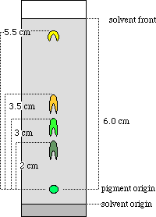

Atomic Structure
Atoms are built up from three “fundamental particles”:
Particle | Relative Mass | Relative charge
Proton | 1 | +1
Neutron | 1 | 0
Electron | 1/1860 | –1

Each atom consists of a very small, very dense nucleus, which contains all the heavy particles (protons and neutrons), surrounded by orbiting electrons (which take up most of the volume). Atoms are represented as;
mass number → 23
Na
proton number →11
All atoms of a particular element have the same no. of protons. e.g. all atoms with 11 protons are Na atoms.

- The number of protons in an atom is called its proton number (atomic number).
the number of protons = atomic number

- In an atom, there is no overall electrical charge so;
the number of electrons = the number of protons in the nucleus.

- The total number of protons and neutrons in an atom is called its mass number.
the number of neutrons = mass number – atomic number

Isotopes are atoms of the same element, with the same number of protons and electrons, but different numbers of neutrons in the nucleus.

For example, natural chlorine (element 17) consists of two types of atom: ³⁵Cl containing 17 protons and 18 neutrons, and ³⁷Cl containing 17 protons and 20 neutrons.

Calculating the Relative Atomic Mass (RAM, Ar) of an element

The Relative Atomic Mass (Ar) of an element is the weighted (to take account of relative abundance) average of the Relative Isotopic Masses of all of the isotopes of that element.
Note - The mass is relative to the mass of pure C-12 which is given a mass of 12.

Example 1 - Natural chlorine has two isotopes:
³⁵Cl has a relative abundance of 75%, and ³⁷Cl has a relative abundance of 25%.

The RAM (Ar) of chlorine is therefore the weighted mean of the isotopic masses:
RAM (Ar) = 35 × 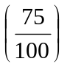+ 37 × 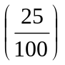= 35.5 = (to 3 s.f.)

Example 2 - Natural bromine has two isotopes:
⁷⁹Br has a relative abundance of 50.5%, and ⁸¹Br has a relative abundance of 49.5%.
RAM (Ar) = 79 × + 81 × = 79.99 = 80.0 (to 3 s.f.)
Arrangement of electrons
Electrons are arranged in shells.
The first shell can hold up to two electrons, the second up to eight, and the third up to eight.
Thus an atom of Li (with three electrons) will have two in the first shell, and one left over in the second shell. We write this arrangement 2:1
An atom of Mg (12 electrons) will be 2:8:2
We can show this in a diagram, for example for magnesium:
nucleus containing 12 protons and 12 neutrons

₁₂Mg: 2.8.2
+12

Uses of Electronic Configurations

The chemical properties of elements depend on the number of electrons in the outer shell, so we place them in vertical groups which all have the same number of electrons in the outer shell:

e.g. Group 1 ₃Li 2.1
₁₁Na 2.8.1
₁₉K 2.8.8.1

After element 20 the electron arrangement becomes more complicated, but it is always true that elements in Group 1 have one electron in their outer shell, so we can say that Rb, Cs and Fr will all have one electron in their outer shell.

Therefore elements in Group 3 always have three electrons in their outer shell.

Elements in Group 7 always have seven electrons in their outer shell.

The elements on the right of the table — labelled Group 0 — are inert (unreactive) and have full outer shells, normally with eight electrons in them (Ne is 2.8, Ar is 2.8.8 etc).

Atoms with 1, 2 or 3 electrons in their outer shells are metals (apart from hydrogen, helium and boron). This means groups 1, 2 and 3 (except B), and also all the transition metals.

Atoms with 4, 5, 6 or 7 electrons in their outer shells are non-metals (i.e. groups 4, 5, 6 and 7).
[This is not always true for the lower members (e.g. Sn and Pb in group 4), but works well for the first four periods.]

Atoms with full outer shells are noble gases. Although these are also non-metals, they fall into a special category because they are unreactive.
Structure and Bonding

There are three main types of chemical bonding:
- IONIC
- COVALENT
- METALLIC: when a metal bonds with a metal – a lattice of positive ions is electrostatically attracted to “a sea of” delocalized electrons.

Ionic bonding
Ionic bonding occurs when a metal bonds with a non-metal – complete transfer of one or more electrons from metal to non-metal, giving charged ions that electrostatically attract.

An IONIC BOND is defined as; the electrostatic attraction between oppositely charged ions.

Metals in groups 1, 2 and 3 can get to a full outer shell most easily by losing all their outer electrons, to leave positive ions – this process is called OXIDATION.
e.g. Na → Na⁺ + 1e– Mg → Mg²⁺ + 2e–
(2:8:1) (2.8) (2.8.2) → (2.8)

Non-metals in groups 6 and 7 can get to a full outer shell by accepting enough electrons from a metal to make them up to 8, forming negative ions - this process is called REDUCTION.
e.g. O + 2e– → O^{2–} Cl + e– → Cl–
(2.6) (2.8) (2.8.7) (2.8.8)

When sodium combines with chlorine, an electron is transferred completely from Na to Cl:

+11
×
×
×
×
×
×
×
×
×
×
×
+17
o
o
o
o
o
o
o
o
o
o
o
o
o
o
o
o
o
Na atom
2.8.1
Cl atom
2.8.7

+
–
+
×
×
Na⁺ ion
2.8
o
o
o
Cl– ion
2.8.8
+11
×
×
×
×
×
o
×
×
o
×
×
+17
o
o
o
o
o
o
o
o
o
o
o
o

If magnesium (2.8.2) combines with chlorine, the magnesium has to lose both its outer shell electrons, even though a chlorine atom can only accept one. Therefore it reacts with two chlorine atoms:
Mg (2.8.2) + two Cl (2.8.7) → Mg²⁺ (2.8) and two Cl– (2.8.8) i.e. MgCl₂

Similarly, when K (2.8.8.1) combines with S (2.8.6), two K atoms each lose one electron, and one S atom gains two electrons, giving 2K⁺ and S^{2–} ( formula K₂S).

With Ca (2.8.8.2) and O (2.6) two electrons are transferred, giving Ca²⁺ and O^{2–}.

Giant Ionic Substances

Once the ions are formed, they attract one another.
A sodium ion attracts negative chloride ions from all directions to form a regular GIANT IONIC LATTICE.
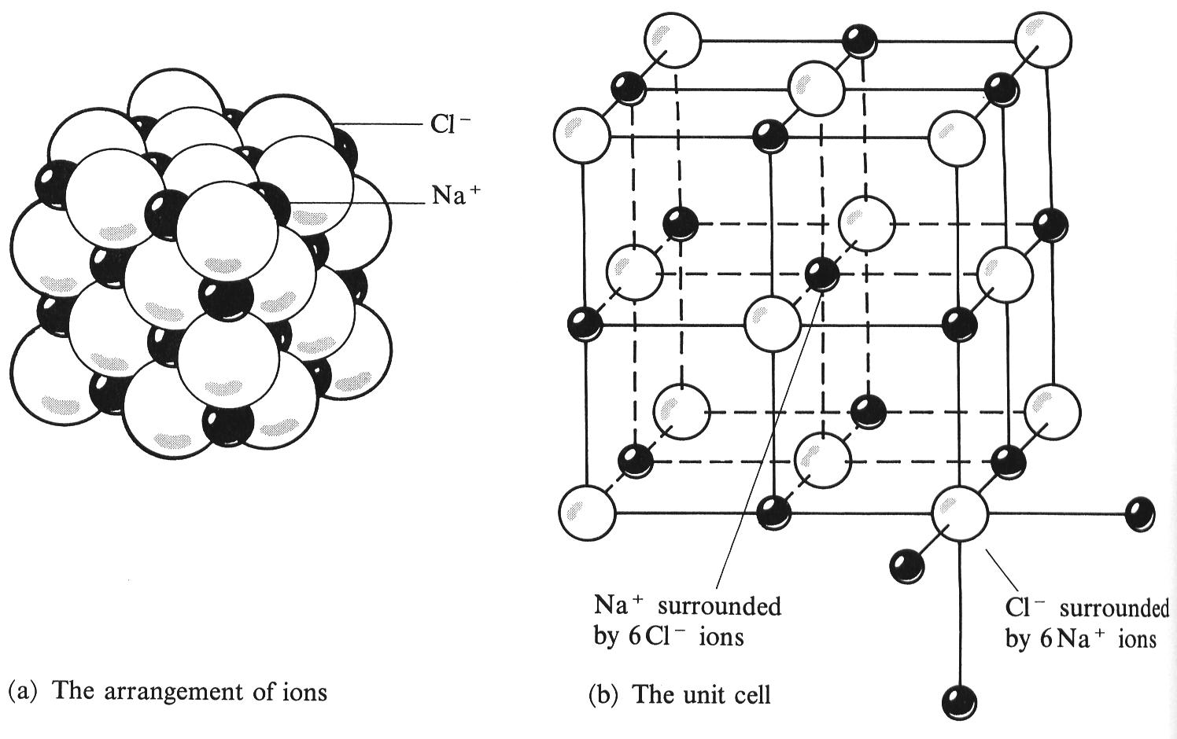

Ionic solids have lots of strong ionic bonds that require a lot of energy to break. Therefore they have the following properties;

- high melting point: NaCl melts at 801ºC (too high to melt in the bunsen flame), while MgO melts at 2900ºC. The double charge on Mg²⁺ and O^{2–} means the ions attract much more strongly than Na⁺ and Cl–, and this is why the melting (and boiling) points are much higher for MgO.

- they don’t conduct electricity when solid, but they do conduct when molten or in solution, since the ions become free to move and can carry charge and undergo electrolysis.

- usually soluble in water. Water is a polar molecule (with one negative end and one positive end) and can cluster around the ions, allowing them to separate, and so overcome the strong attractive electrostatic forces which hold the lattice together.

Covalent Bonding

When two non-metal atoms combine they both need to gain electrons, and they can do this by sharing two electrons (normally one from each atom) in a covalent bond.

A COVALENT BOND is defined as; the electrostatic attraction between the positively charged protons in the nucleus and the negative shared pair of electrons.

We can draw diagrams of covalent compounds between non-metal atoms by showing how the outer shells overlap, and using a dot or cross to show the electrons from the different atoms.

You need to be able to draw “dot-cross” bonding diagrams for H₂, Cl₂, NH₃, CH₄, H₂O and O₂.

In the diagrams below, notice that H atoms always have two electrons in their circles, while all the others have eight. Outer shells only are shown; a dot is used for electrons from one atom, and a cross for the other.
×
×
o
o
×
o
H
×
×
o
×
×
o
H
H
Cl
Cl
×
×
o
o
o
o
H
H
C
×
×
o
o
×
o
× = C electron
H
o = H electron
×
×
×
×
o
o
H
H
H
o
o
N
×
O
×
×
×
o
×
×
×
o
o
×
×
×
×
×
o
o
o
O
O
×
o
H
H
ammonia: N is 2.5 so 5 × in N’s circle
O₂: O is 2.6 so forms 2 bonds
O=O is a double bond

In carbon dioxide, carbon (2.4) needs to form four bonds, and oxygen (2.6) needs to form two, so two double-bonds result (O=C=O), a linear molecule.
o
o
o
o
O
O
C
×
o
o
×
o
o
×
o
o
×
o
o

The covalent bond is strong, but it binds two specific atoms together (unlike the ionic attractions, which occur in all directions).
You need to know the shapes of the following molecules; CH₄ is a regular tetrahedron and CO₂ is linear.

Simple Molecular Structures
A molecular structure consists of small molecules, with weak forces of attraction (intermolecular forces) between molecules.
When a molecular substance is melted or boiled, it is only necessary to provide a small amount of energy to break these weak attractions, so they have low melting points and boiling points.

Molecular substances are gases, liquids, or low-melting solids at room temperature.
They usually share the following properties:
- low melting points (melting only involves breaking the weak attraction between molecules).
- low boiling points (like melting)
- don’t conduct electricity in solid, or when melted, or in solution, as they have no charged particles.
- often dissolve in non-polar solvents, like hexane; usually insoluble in water.

As with all molecular structures these have weak forces of attraction between molecules so they too will have low melting points and boiling points.

Giant Covalent structures
If a non-metal atom can form three or four bonds, it is possible for it to form giant structures linked by covalent bonds.
There are two forms of carbon which have giant structures.
In diamond each atom is covalently bonded to four neighbours, and each of those to three others, and so on throughout the whole crystal.
Graphite consists of layers of hexagons (like a honeycomb) with strong covalent bonds holding each C atom to its three neighbours.
Both diamond and graphite have very high melting points (above 4000ºC) and sublimation points because it is necessary to break all of the strong covalent bonds to melt them. This requires a lot of energy.
When elements are found to exist in more than one crystalline form they are referred to as ALLOTROPES. Diamond and Graphite are therefore Allotropes of Carbon

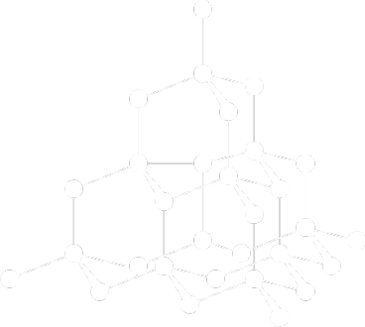
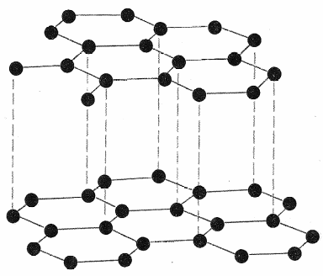
CARBON in the form of DIAMOND CARBON in the form of DIAMOND

Giant covalent molecules have the following properties:
- hard (diamond is the hardest substance known)
- high melting points (some of the highest known)
- insoluble in all solvents
- don’t conduct electricity in the solid, nor when molten – as they do not contain charged particles.

A third Allotrope of carbon was discovered twenty years ago: carbon can form a molecule of formula C₆₀, called Buckminster.
C₆₀ is a spherical molecule with all the C atoms on the surface, forming a pattern of pentagons and hexagons like a modern football. This is not a giant molecule it is simple molecular.
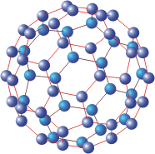

Metallic bonding
In metallic bonding metals give up their outer electrons to be shared with all their neighbours.
The electrons become “delocalised” in a mobile “sea” of electrons which flows between the positive ions.
The positive ions themselves pack as tightly as possible in a GAINT STRUCTURE.

A METALLIC BOND is defined as; the electrostatic attraction between the positively charged metal ions and the negatively charged delocalized electrons.
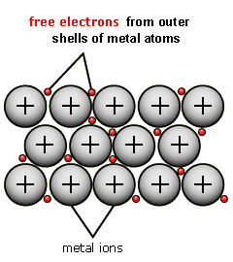

Giant Metallic Structures

In metallic bonding metals give up their outer electrons to be shared with all their neighbours.
The electrons become “delocalised” in a mobile “sea” of electrons which flows between the positive ions.
The positive ions themselves pack as tightly as possible in a GAINT STRUCTURE.

A METALLIC BOND is defined as; the electrostatic attraction between the positively charged metal ions and the negatively charged delocalized electrons.

Giant metallic substances have the following properties:
- They conduct electricity because the electrons are free to flow between the ions and carry charge.
- They are malleable and ductile because the ions can slide over each other, but continue to attract each other strongly in their new positions, so that the metallic bonds do not break but distorts instead.
- They have high melting points because the metallic bonds are strong and require a lot of energy to break.

Organic Chemistry
Crude oil is a complex mixture of hydrocarbons (compounds containing hydrogen and carbon only).
It forms a valuable resource, both as the origin of many types of fuel, and as the starting point for petrochemicals (plastics, detergents, solvents etc).
However, it must first be separated into mixtures with a much narrower boiling range.
In industry, crude oil is separated by FRACTIONAL DISTILLATION in a continuous process, taking off the samples at different levels from the fractionating column. The dissolved gases come out of the top, and the boiling points rise as one goes down the column. Note that the process does not produce single substances, but less complex mixtures than in crude oil. A simplified diagram is shown below:
Refinery gases (used for bottled gases such as Gaz, propane, butane)

FRACTIONATING COLUMN
increasing temperature

Gasoline: fuel for cars (petrol)

Kerosene: fuel for jet planes

Diesel: for lorries and larger cars
crude oil in

Fuel oil: for heating homes and factories
HEAT

Bitumen: for making roads and tar.

- The Crude oil is initially heated and evaporated.
- The small molecules have a low boiling point and rise to the top of the tower.
- As the tower is descended the molecules get longer and have a higher boiling point and so condense at higher temperatures.

There is a problem with the fractional distillation of crude oil;
- it produces too many of the less useful long chained fractions.

The products obtained from oil are invaluable to society, providing transportation fuels (cars, planes),
plastics, pesticides, detergents — a huge range of petrochemicals.
There is an environmental cost to this. Extraction of oil may pollute the environment (e.g. in Alaska). Transport of oil by pipeline (leaks in Siberia) and tanker (routine spillages, major accidents from Torrey Canyon to Esso Valdez) is hazardous, and is bound to result in problems.
Some substances obtained from oil have their own environmental problems:
Petrol, diesel: greenhouse effect, air pollution (nitrogen oxides, carbon monoxide, unburnt hydrocarbons, particulates)
Plastics: most are not biodegradable (not broken down by bacteria in the environment), and so last for very long periods in landfill sites. When burnt some give toxic fumes, so safe disposal, especially of packaging, is difficult.
Carbon compounds

Carbon always forms four bonds and hydrogen forms one bond. For example:
H—C—C—C—C—C—H
H
H
H
H
H
H
H
H
H
H

Pentane
The simplest carbon compounds are the hydrocarbons (defined as compounds which contain carbon and hydrogen only).

The molecular formula of a compound shows how many of each type of atom there are in a molecule. For pentane (above) this is C₅H₁₂.

The displayed formula of a compound shows all the bonds between the atoms in a molecule (as shown for pentane and cyclobutane above).

ALKANES

Most of the hydrocarbons present in crude oil are alkanes.

The alkanes are said to form a homologous series, that is a series of organic compounds with the same general formula and similar chemical properties.
The general formula for alkanes is C_{n}H_{2n+2.}

Each member (after the first) differs from the one before by addition of a –CH₂– group.

The physical properties of a homologous series usually show a regular trend.
For example, their boiling points increase steadily along the series; this is because, as the molecules get larger, the attractions between molecules increase and so take more energy to break.

The alkanes may be defined as hydrocarbons of general formula C_{n}H_{2n+2}.
H
H
H
H
H
H
H
H
H
H
H
You should learn the names and structures of the first five members:
H
H
H
H—C—H
H—C—C—H
H—C—C—C—H
H—C—C—C—C—H
H
H
H
H
H
H
methane CH₄ ethane C₂H₆ propane C₃H₈ butane C₄H₁₀

Pentane, C₅H₁₂, is shown at the top of this page.

In alkanes the four bonds on each carbon are directed to the corners of a tetrahedron.

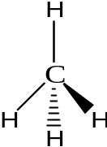
Isomers

Alkanes with four or more C atoms can show isomerism.

Isomerism: when two or more different compounds have the same molecular formula but different structural formula, they are called isomers. For example there are two compounds of formula C₄H₁₀:
H
H
H
H
H
H
H
H—C—C—C—H
H
H
H—C—C—C—C—H
H
H
H
H
—C—
H
H

H
butane methylpropane
H—C—C—C—C—H
The one on the right is a branched-chain compound (i.e. the carbon atoms are not all in a row).

For C₅H₁₂ there are three isomers, two of which are branched:
CH₃
CH₃
CH₃–CH₂–CH₂–CH₂–CH₃
CH₃–CH₂–C–CH₃
CH₃–C–CH₃

H
CH₃

pentane methylbutane dimethylbutane

Reactions of Alkanes

Alkanes are widely used as fuels.
When they burn in air they form waste gas (carbon dioxide and water vapour), and the reaction gives out heat to the surroundings (exothermic).

e.g. CH₄ + 2 O₂ → CO₂ + 2H₂O (combustion of natural gas)
C₅H₁₂ + 8 O₂ → 5CO₂ + 6H₂O
C₈H₁₈ + 12½O₂ → 8CO₂ + 9H₂O

In a restricted supply of air, carbon monoxide is formed: this is highly toxic (and particularly dangerous since it has no colour or smell). Carbon monoxide is poisonous because it reduces the capacity of blood to carry oxygen by bonding to haemoglobin.

During the combustion of fuels such as petrol and diesel, sulphur dioxide and nitrogen oxides may also be formed. These gases are pollutants which contribute to acid rain.

Apart from combustion, alkanes are very unreactive.

They will however react with chlorine and bromine in the presence of sunlight.
CH₄ + Cl₂ → CH₃Cl + HCl
C₂H₆ + Br₂ → C₂H₅Br + HBr

Catalytic Cracking

Cracking: this is an example of a thermal decomposition (a reaction in which a substance is heated until it breaks down into other substances).
When an alkane is cracked, by passing its hot vapour over a catalyst, it splits into a shorter-chain alkane and an alkene:

long-chain alkane → shorter-chain alkane + alkene (or hydrogen)
e.g. C₁₀H₂₂ → C₈H₁₈ + C₂H₄
or C₃H₈ → C₃H₆ + H₂

Conditions for Catalytic Cracking – Temperature 600-700 ºC
Catalyst SiO₂ or Al₂O₃

Importance of Catalytic Cracking

Cracking is important because;
(a) it produces valuable alkenes, which are the starting point for petrochemicals;
(b) it also gives shorter alkanes, which are more useful as fuels.

We can illustrate this using displayed formulae, for cracking pentane, the fifth alkane:
H—C—C—C—C—C—H
H
H
H
H
H
H
H
H
H
H
H—C—C—C—H +
H
H
H
H
H
H
C C
H
H
H
H

pentane → propane + ethene

ALKENES

These are also hydrocarbons, and have they form another homologous series.
The general formula of alkenes is C_{n}H_{2n}.

The first two members are: ethene, C₂H₄ and propene, C₃H_{6.}

Whereas the alkanes only contain single C–C bonds, the alkenes each have a C=C double covalent bond:

C C
H
H
H
H

C C
C
H
H
H
H
H
H

ethene propene

In alkenes the bonds on each carbon are directed to the corners of an equilateral triangle.
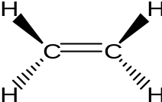

Reactions of alkenes

The presence of C=C bonds means that alkenes are reactive, since they can undergo addition reactions.

Molecules with double bonds that can undergo addition reactions are said to be unsaturated, while compounds (such as alkanes) which only have single bonds are called saturated.

In an addition reaction a molecule adds to the C=C bond to give a single product with a C–C bond.

(i) With bromine

When alkenes are shaken with bromine water in a test tube, the orange colour of the bromine disappears.

The observation for the reaction is ORANGE to COLOURLESS.

This reaction is used as a test for unsaturated compounds (Compounds containing C=C)).
C C
H
H
H
H
H
H
+ Br—Br → H—C—C—H

Br
Br

(ii) Addition polymerisation
This is the process in which a large number of small molecules (called MONOMERS) link together to form a large molecule called a POLYMER.

Ethene molecules can be made to join together to form the polymer called poly(ethene) or polythene which is used in plastic bags, etc.
High temperature and high pressure are needed for the reaction to occur.

—C—C—C—C—
H
H
H
H
H
H
H
H
( )_{n}

C C
H
H
H
H
C C
H
H
H
H
H
H
H
H
+
or
—C—C—

ethene + ethene → poly(ethene) shows repeat unit

In this reaction the double bond is opened up, to form a link either side to another molecule: note that double bonds are not present in the long chain polymer.

When propene polymerises it forms poly(propene) — note how this differs from poly(ethene),since it has one CH₃ attached to alternate C atoms in the chain:
H
H
H
H
H
CH₃
H
+
or
—C—C—
H
CH₃
CH₃
CH₃
CH₃
C C
—C—C—C—C—
( )_{n}
C C
H
H
H
H
H
H
H
H

propene + propene poly(propene)

In general any ethene molecule which has an H atom replaced with an group will polymerise in a similar way. For example if is Cl, the polymer is called poly(chloroethene) [or commonly PVC, for polyvinylchloride]:
X
X
X
X
X
X
X
( )_{n}
H
H
H
H
H
H
H
H
H
C C
H
H
H
+
—C—C—C—C—
or
—C—C—
C C
H
H
H

monomer + monomer → polymer from n monomers

You need to know common uses for these three polymers:
- poly(ethene) for plastic bags and plastic bottles (since it forms a flexible film and is transparent)
- poly(propene) for plastic crates and ropes (since it is stronger and less flexible than poly(ethene), and the fibres in ropes are flexible)
- poly(chloroethene), or PVC, for drain pipes and for insulation on electric cables (since it is strong but flexible, and doesn’t conduct electricity).

ALCOHOLS
Form a homologous series of general formula C_{n}H_{2n+1}OH.

The first two members are: methanol, CH₃OH and ethanol, C₂H₅OH.

Industrial formation of ethanol.
- Ethanol can be made from ethane and steam.
- High temperature, a catalyst (phosphoric acid) and high pressure are needed.
- The ethene combines with steam to produce ethanol, which is used as a solvent:
C C
H
H
H
H
H
H
+ H—O–H → H—C—C—H

H
O–H

ethene + steam → ethanol

Another way of producing ethanol is from fruit juices: fermentation is the process by which yeast, in the absence of oxygen, produces ethanol and carbon dioxide from glucose.
- A sugar solution (such as grape juice) is mixed with yeast and warmed slightly (20-25ºC).
- An airlock is used to keep air out.
- The yeast undergoes anaerobic respiration, and releases enzymes which catalyse the breakdown. You need to know the equation:
glucose → ethanol + carbon dioxide
C₆H₁₂O₆ → 2C₂H₅OH + 2CO₂

This is the basic process by which wine and beer are made.

Advantages of fermentation: cheap and renewable resource like sugar cane

Disadvantages of fermentation: slow reaction made by an inefficient batch process, poor quality product eg low aqueous concentration <14%.

Advantages of ethene route: fast and efficient continuous process,
relatively pure product

Disadvantages of ethene route: non-renewable finite resource

Reactions of Alcohols

Ethanol can be dehydrated (i.e. have water removed chemically from the molecule) to ethane by passing the vapour over hot aluminium oxide. This is the reverse of its formation from steam, above:
C C
H
H
H
H
H
H
H
O–H
H—C—C—H → + H₂O

Carboxylic Acids

Homologous series formed from the oxidation of alcohols containing a COOH (CO₂H) group.

The first two members are: methanoic acid, HCO₂H and ethanoic acid, CH₃CO₂H.

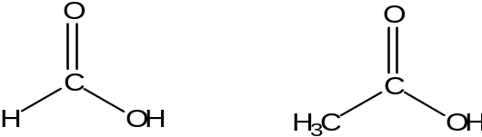

Condensation Polymerisation

Carboxylic acids can be used as monomers to make a second type of polymer called condensation polymers.

Condensation polymers are polymers formed from condensation reactions between monomers with reactive groups at both ends. A small molecule (often water but sometimes HCl) is produced as well as the polymer.

Polyesters
Polysters are formed between monomers containing two carboxylic acid groups and two alcohol groups.

e.g. Terylene
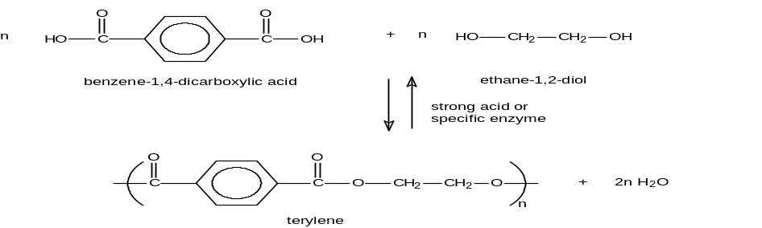
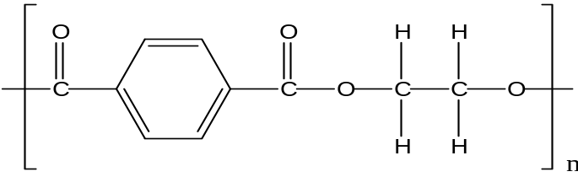

Nylon

Nylon is a condensation polymer formed between monomers below.
(Note that the small molecule formed along with the condensation polymer is HCl rather than water).
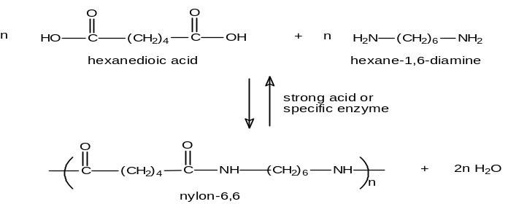
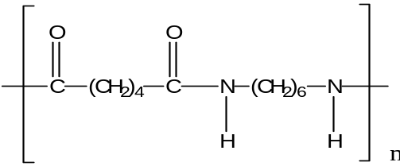 + HCl

Calculations

Atomic and molecular masses
The relative atomic mass (Ar) of an atom is found of the periodic table.
We usually use relative atomic masses correct to the nearest whole number (or 0.5 in the case of Cl):
H = 1; C = 12; N = 14; O = 16; Na = 23; Al = 27; S = 32; Cl = 35.5; Cu = 64

The relative formula mass (RFM, Mr) of a compound is obtained by adding up the masses of all the atoms in the formula:
CO2 r.f.m. = 12 + 2 ×16 = 44
Cu(NO₃)₂ r.f.m. = 64 + 2 × (14 + 3×16) = 188

Calculating percentage by mass of elements in compounds.

The percentage by mass is important to mineral prospectors, and is also useful in finding formulae.
If the formula is already known it is simply a question of finding the fraction of the formula mass made up by the element in question.

% mass = Mass of the substance in the compound x 100
RFM of the substance

e.g. What is the percentage by mass of aluminium in bauxite, Al₂O₃?

RFM of Al₂O₃ = 2×27 + 3×16 = 102
Mass of aluminium in Al₂O₃ = 2×27 = 54

% by mass of Al = 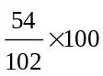 = 52.9% (3 sig. fig.)

A common problem with percentage by mass calculations occurs when an element occurs in two places in the compound.

e.g. What is the percentage by mass of oxygen in CuSO₄.5H₂O?

RFM of CuSO₄.5H₂O = 64 + 32 + 4×16 + 5× (2+16) = 250
Mass of oxygen in formula = 4×16 + 5×16 = 144
% by mass of O = 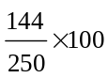 = 57.6% (3 sig. fig.)

The mole and molar mass

The mole is the chemists counting unit.

One mole is the amount of substance which contains the Avogadro Constant of a specified particle (or formula).

The Avogadro Constant is equal to the number of atoms in 12 g of carbon–12, is about 6 x 10²³

It follows that one mole of any substance contains the same number of atoms (or molecules, or ions, or electrons, or other formula units).

If you work out the relative formula mass of a substance, the mass of 1 mole will be the same number, in g. This is called the molar mass, and its units are g/mol.

e.g. What is the mass of one mole of (a) CO₂ ; (b) Cu(NO₃)₂ ?
[C=12, O=16, Cu=64, N=14]

(a) Formula mass of CO₂ = 12 + 2×16 = 44
Molar mass of CO₂ = 44 g/mol

(b) Formula mass of Cu(NO₃)₂ = 64 + 2 × (14+ 3×16) = 188
Molar mass of Cu(NO₃)₂ = 188 g/mol

Amount of substance
The “amount of substance” is a special name for the number of moles. If we know the mass of a substance and its molar mass, we can find the amount:

Amount of substance (mol) =

If we know the number of moles and the molar mass, we can find the mass of substance:

mass (g) = amount (mol) × molar mass (g/mol)
Some find the triangle (see right) helps them to remember: cover up one and you have the formula in terms of the other two. | mass  moles ×  molar  mass

Empirical and Molecular formulae

The simplest whole-number ratio of atoms in a compound is called the empirical formula.

We can use moles to find the formula of a substance. The steps are as follows:

(a) (Carry out an experiment to) find the masses of all the different elements which combine with each other. It is the ratio which is important, so the total mass doesn’t matter.
Sometimes data may be given as % by mass: these should be treated as the masses of the element in 100g of compound.

(b) Convert each mass to amount of substance: i.e. divide the mass by the relative atomic mass of the element concerned.

(c) You now have the ratio of moles of atoms of the different elements.
The ratio of atoms must be the same, since one mole of any substance contains the same number of units. There can’t be less than one atom of any element in the simplest formula, so divide through by the number of moles which is smallest.

(d) Then try multiplying by small whole numbers (2, 3 or 4) to get a whole-number ratio.

e.g. 2.88 g of magnesium is heated in nitrogen, and forms 4.00 g of magnesium nitride.
Find the empirical formula of magnesium nitride. [Mg=24, N=14]

(a) Find the masses of all the different elements
mass of nitrogen in sample = 4.00 – 2.88 = 1.12 g
So 2.88 g of Mg combines with 1.12 g of N

(b) Divide the mass by the molar mass of the element concerned
Molar masses: Mg = 24 g/mol, N = 14 g/mol
So amounts which combine are:
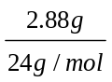of Mg atoms combines with 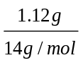of N atoms
i.e. 0.120 mol of Mg atoms combines with 0.0800 mol of N atoms

(c) Divide through by the number of moles which is smallest
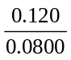mol of Mg combines with 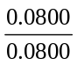mol of N
i.e. 1.50 mol of Mg atoms combines with 1.00 mol of N atoms

(d) Try multiplying by small whole numbers to get a whole-number ratio
multiply by 2:
3 mol of Mg atoms combine with 2 mol of N atoms
so 3 Mg atoms combine with 2 N atoms
So simplest formula = Mg₃N₂

The molecular formula is the formula showing the actual number of each type of atom in one molecule.

For example, butene, like all alkenes has the empirical formula CH₂, but its molecular formula is C₄H₈

The molecular formula must be a whole number × the empirical formula:

We find the whole number using the RFM and the mass of the empirical formula.

Whole number = RFM .
mass of empirical formula

e.g. A compound of carbon, hydrogen and oxygen is found to be 40.0% carbon and 6.7% hydrogen by mass. Its relative molecular mass is 120.
Find (a) its empirical formula; and (b) its molecular formula.

In 100 g of compound there is: 40.0 g of C and 6.7 g of H and (100 – 40.0 – 6.7)
= 53.3 g of O

Convert to moles of atoms) mol C : mol H : mol O

3.33 mol C : 6.7 mol H : 3.33 mol O

Divide by smallest 1.0 mol C 2.0 mol H 1.0 mol O

(a) empirical formula = CH₂O

molecular formula = (CH₂O)_{y}

formula mass of CH₂O = 12 + 2 + 16 = 30
r.m.m. = 30 × y = 120 (given in question)
y = 4

(b) molecular formula = C₄H₈O₄
Finding the formulae of metal oxides

There are two main methods available for determination by experiment;
(a) by direct reaction between the element and oxygen/air.

(b) by reduction of the metal oxide (only for metals low in reactivity series), using hydrogen or methane.

Example (a): a crucible was weighed with its lid (6.20g). A coiled piece of magnesium ribbon was added, and it was weighed again (6.68g). The crucible was heated [diagram (a)] until the magnesium started to burn, then the lid was raised for brief periods until it had ceased to burn. It was heated to constant mass with the lid off. The final mass of crucible, lid and magnesium oxide was 7.00g. Find the empirical formula of the magnesium oxide. [Mg=24; O=16]

mass of magnesium used = 6.68 – 6.20 = 0.48g
mass of oxygen gained = 7.00 – 6.68 = 0.32g

amount of magnesium : amount of oxygen
= 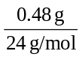 : 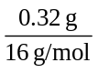
= 0.020 mol : 0.020 mol
= 1 : 1

Empirical formula = MgO

Example (b): a porcelain boat was weighed empty (3.620g). Some red copper oxide was added, and it was weighed again (4.832g). The apparatus was assembled as in the diagram (b). The hydrogen cylinder was switched on, and the air was swept out of the test tube before igniting the gas at the exit hole. The boat was heated until all the copper oxide had been reduced, and the hydrogen flow was left on while the boat cooled, to prevent air reaching the hot copper. On reweighing the boat, its mass was 4.696g. Find the empirical formula of the copper oxide. [Cu=63.5; O=16]

Check your answer; Empirical formula = Cu₂O

Water of crystallisation – Calculations

Some salts contain water molecules that form part of their crystal structure. This water is called water of crystallisation and is written in the formula of the salt.
e.g. MgSO₄.H₂O refers to hydrated magnesium sulphate.
Na₂SO₄.6H₂O refers to hydrated sodium sulphate.

The % water of crystallisation and the formula of the salt are calculated as follows:
- A known mass of hydrated salt is heated gently in a crucible until it reaches constant mass.
- The mass of anhydrous salt remaining and the mass of water lost are then calculated.
- These are converted to moles and the formula of the hydrated salt can be found from the mole ratio.

Worked example.
6.25g of blue hydrated copper(II) sulphate, CuSO₄.xH₂O, (x unknown) was gently heated in a crucible until the mass remaining was 4.00g. (This is the white anhydrous copper(II) sulphate CuSO₄).
The mass of anhydrous salt (CuSO₄) = 4.00g,
Mass of water (of crystallisation) driven off = 6.25 - 4.00 = 2.25g

RFM (Mr) CuSO₄ = 64 + 32 + (4x18) = 160 and RFM (Mr) H₂O = 1+1+16 = 18

Moles of CuSO₄ = 4 / 160 = 0.025
Moles of H₂O = 2.25 / 18 = 0.125

The mole ratio of CuSO₄ : H₂O is 0.025 : 0.125 or 1 : 5

So the formula of the hydrated salt is CuSO₄.5H₂O
Calculations from Equations: Reacting masses

Normally you will be given an equation, and asked a question which concerns only two substances, for one of which the mass is given, and for the other the mass needs to be calculated:
e.g. (6) What mass of substance A is needed to give x g of substance B?
What mass of substance C is produced from y g of substance D?

The steps involved in a calculation are as follows :
(a) Convert the information given to moles of one substance.
(b) Use the chemical equation to find moles of other substance needed.
(c) Convert back from moles to mass (or concentration, volume etc.)

e.g. What mass of oxygen is needed to burn 3.00 kg of propane, C₃H₈?

In this case the chemical equation is not given, so we must start by writing it down:

C₃H₈ + 5 O₂ → 3CO₂ + 4H₂O

- Convert the information given to moles of one substance.
We are given the mass of propane, so it is this we must convert to moles.

Formula mass of C₃H₈ = 3 × 12 + 8 × 1 = 44 So molar mass = 44 g/mol
Number of moles of C₃H₈ in 3.00kg = 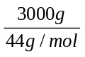 = 68.2 mol

(b) Use the chemical equation to find moles of other substance needed.
1 mol of propane reacts with 5 mol of oxygen molecules.

So 68.2 mol of propane reacts with 5 × 68.2 = 341 mol of oxygen molecules

(c) Convert back from moles to mass (or concentration, volume etc.)
Molar mass of O₂ molecules = 2 × 16 = 32 g/mol
So mass of oxygen needed = 341 mol × 32 g/mol = 10.9 kg

e.g. In the reaction Fe₃O₄ + 4CO → 3Fe + 4CO₂ what mass of the iron oxide is needed to form 2.50 g of carbon dioxide?

(a) molar mass of CO₂ = 12 + 2 × 16 = 44 g/mol
amount of CO₂ = 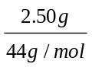 = 0.0568 mol

(b) From equation, 4 mol of CO₂ is formed from 1 mol Fe₃O₄
So 0.0568 mol of CO₂ is formed from 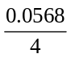 = 0.0142 mol Fe₃O₄

(c) Molar mass of Fe₃O₄ = 3×56 + 4×16 = 232 g/mol
mass of 0.0142 mol Fe₃O₄ = 0.0142 mol × 232 g/mol = 3.29g (3 s.f.)

Percentage Yield

The % yield of a reaction is the percentage of the product obtained compared to the theoretical maximum as calculated from the balanced equation.
However in any chemical process it is almost impossible to get 100% of the product because;
• the reaction may not go to completion (it may be reversible)
• there may be side-reactions which use up some of the starting material
• it may not be possible to separate all of the product from the mixture

% yield = actual amount of desired chemical obtained x 100
maximum theoretical amount formed
Worked Example
2.8g of iron was heated with excess sulphur to form iron sulphide. Fe + S → FeS
The excess sulphur was dissolved in a solvent and the FeS filtered, washed and dried.
4.1g of purified iron sulphide was finally obtained, what was the % yield?

    - Calculate the maximum theoretical amount.
      - 2.8g of iron = 2.8/RAM = 2.8/56 moles = 0.05
      - Fe + S → FeS 0.05 moles of Fe theoretically makes 0.05 moles of FeS
      - Theoretical amount of FeS = 0.05 x RFM = 0.05 x 88 = 4.4g

    - % yield = actual amount of chemical obtained x 100
maximum theoretical amount

= 4.1 x 100 = 93.2% (to 1dp)
4.4

Calculation of gas volumes

At room temperature and pressure (r.t.p.), one mole of any gas occupies a volume of 24 dm³ (24000 cm³).

Number of moles of gas at r.t.p = 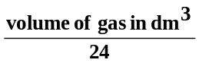
= 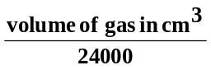

and: volume of gas at r.t.p = (number of moles) × 24 dm3
= (number of moles) × 24000 cm3

e.g. What total volume of gas at r.t.p. can be obtained from heating 99.3g of lead(II) nitrate?
(Pb=207, N=14, O=16)
2 Pb(NO₃)₂ → 2PbO + 4NO₂ + O₂

(a) Molar mass of lead(II) nitrate = 207 + 2 × (14 + 3×16) = 331g/mol
Amount of lead(II) nitrate = 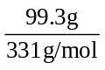 = 0.300 mol
(b) From equation: 2 mol of lead(II) nitrate give (4 + 1) = 5 mol of gas
Therefore 0.300 mol gives 0.300 × 2.5 = 0.75 mol of gas

(c) Volume of 0.75 mol of gas = 0.75 × 24 = 18 dm³ (at room T and P)

e.g. What mass of sodium hydroxide is needed to absorb 1.00 dm³ of carbon dioxide gas at r.t.p.?

Equation: 2NaOH + CO₂ → Na₂CO₃ + H₂O

(a). Amount of carbon dioxide = 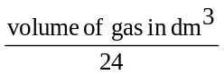
= 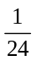mol
= 0.0417 mol

(b) From equation: 1 mol of carbon dioxide reacts with 2 mol of NaOH
So 0.0417 mol of CO₂ reacts with 2 × 0.0417 = 0.0833 mol of NaOH

(c) Molar mass of NaOH = 23 + 16 + 1 = 40 g/mol
mass of NaOH needed = 0.0833 mol × 40 g/mol = 3.33 g

Avogadros Law of Gases

When two gases react, the ratio of volumes is the same as the ratio of moles.
This is because equal volumes of all gases, under the same conditions, contain the same number of molecules.

e.g. (11) When propane gas is burnt the equation is:

C₃H₈ + 5 O₂ → 3CO₂ + 4H₂O

What volume of oxygen will react with 2.5 dm³ of propane, at r.t.p.?

From the equation: 1 mol C₃H₈ reacts with 5 mol of O₂

Therefore: 1 dm³ C₃H₈ reacts with 5 dm³ of O₂

and: 2.5 dm³ C₃H₈ reacts with 2.5 × 5 = 12.5 dm³ of O₂

Periodic Table

History of the Periodic Table
Mendeléef first arranged the elements in a table according to their chemical properties and what he knew about their atomic masses.
Nowadays the elements in the Periodic Table are put in order of increasing atomic number and arranged according to electronic structure.
This is because, in three places in the table, an element with higher relative atomic mass has to be placed before one with a lower mass. For example, argon (relative atomic mass 39.9) comes before potassium (r.a.m. 39.1).

Properties of the Table
The chemical properties of elements depend on the number of electrons in the outer shell, so we place them in vertical groups which all have the same number of electrons in the outer shell:
e.g. Group 1 ₃Li 2.1
₁₁Na 2.8.1
₁₉K 2.8.8.1

After element 20 the electron arrangement becomes more complicated, but it is always true that elements in group 1 have one electron in their outer shell, so we can say that Rb, Cs and Fr will all have one electron in their outer shell.

Similarly elements in group 3 always have three electrons, and elements in group 7 have seven electrons in their outer shell.

The elements on the right of the table — labelled Group 0 — have full outer shells, normally with eight electrons in them (Ne is 2.8, Ar is 2.8.8 etc). Helium (element 2) is also placed here, because it too has a full outer shell.

Hydrogen, element 1, is unique and is not normally placed in any of the main groups.

A horizontal row in the table is called a period.
Elements across the same period are building up the same outer electron shell.

Patterns in the Periodic Table
If the elements are listed in order of atomic number, similar elements appear at regular intervals (although the intervals get longer later in the list). This is a periodic property.

When the elements are laid out according to their electronic structures, as described above, we find that there is a regular pattern of properties across one period, and a similar pattern across the next period.

The most obvious pattern is the change from reactive metals on the left (Group 1), through less reactive elements in the middle, to increasingly reactive non-metals in Group 7 — followed by the very unreactive gases in Group 0. Since soluble oxides of metals are alkaline, and soluble oxides of non-metals are acidic, there is also a pattern of alkaline oxides on the left giving way to increasingly acidic oxides across the period.
Within the same group elements are generally very similar, though they may show a regular trend in their properties. The similarity occurs because the atoms have the same number of electrons in their outer shell. You are expected to know about Group 1, Group 7, Group 0, and the Transition Metals.

Group 1
Li (lithium), Na (sodium), K (potassium), Rb (rubidium), Cs (caesium)
* These are called the alkali metals.

* They all have one electron in their outer shell.

* They are all reactive metals, with a valency (combining power) of 1.

Physical properties:
- They are silver, shiny metals when freshly cut, though they tarnish rapidly and are kept under oil to protect them from air and water.

- They have unusually low densities for metals (Li, Na and K will float on water). These densities increase down the group.

- They become softer going down the group: lithium is quite hard, sodium is as soft as cheese, and caesium is like putty.

- The melting points fall going down the group: from Li (180ºC), Na (98ºC), K (64ºC), Rb (39ºC) to Cs (25ºC). You don’t need to know the values. These are all unusually low for metals.

Reaction with water (increasingly violent down the group):

* Lithium floats, reacts quite vigorously, and fizzes giving off hydrogen.

* Sodium melts to a ball, fizzes around the surface bubbling vigorously giving off hydrogen.

* Potassium reacts violently, melting to a silver ball, catching fire to burn with a mauve flame, and fizzing around.

* Caesium explodes.

N.B. all give the metal hydroxide (not oxide) and hydrogen.
Example equation: 2Na(s) + 2H₂O(l) → 2NaOH(aq) + H₂(g)

- As the group is descended the atoms become larger
- and the outer shell electron is held less strongly
- since it is further away (and shielded from) from the attraction of the protons in the nucleus.
- It becomes easier to lose it to form positive ions and so the elements become more reactive.

Properties of alkali metal compounds

They are almost all white, crystalline solids (all ionic) which are soluble in water.

Group 7 – The Halogens
F (fluorine), Cl (chlorine), Br (bromine), I (iodine).

They all have seven electrons in their outer shells.
They are reactive non-metals, with a valency (combining power) of 1.
They all consist of molecules with two atoms: F₂, Cl₂, Br₂, and I₂.

Physical Properties
F₂ Cl₂ Br₂ I₂
State gas gas liquid solid
melting point (ºC) –220 –101 –7 114
boiling point (ºC) –188 –35 59 184
colour yellow green/yellow red purple/black

With increasing atomic number (down the group):
- melting points and boiling points increase (because the attractive forces between the molecules increase as the molecules get larger). State at room temp: g – g –l –s

- they become darker. Solid iodine looks black, but its vapour is purple, and it is purple when dissolved in organic solvents like hexane.

Chemical Reactions of the elements
Since fluorine is extremely reactive, we shall consider the other three members.

(i) All will bleach dyes, like litmus, though chlorine is rapid, bromine slow, and iodine needs warming.

(ii) All will react with most metals, on warming, to form salts:
2Na + Cl₂ → 2NaCl sodium chloride
Zn + I₂ → ZnI₂ zinc iodide

(iii) Each will displace the ones below it in the group (i.e. the less reactive ones) from their salts. So chlorine will displace bromine from bromides, and iodine from iodides; bromine will displace iodine from iodides.

We can show this with an ionic equation:
Cl₂(g) + 2Br–(aq) → 2Cl–(aq) + Br₂(l) [solution goes orange]
Cl₂(g) + 2I–(aq) → 2Cl–(aq) + I₂(s) [solution goes brown]
Br₂(g) + 2I–(aq) → 2Br–(aq) + I₂(s) [solution goes darker orange]
[iodine solutions can vary in colour from murky brown to pale yellow, according to conditions].

- As the group is descended, the atoms become larger
- and the protons in the nucleus attracts a new electron (to fill the outer shell) less strongly,
- since the outer shell is further away (and more strongly shielded).
- Therefore the atoms become less reactive going down the group (opposite of Group 1).

Properties of halogen compounds (halides)

Sodium chloride, sodium bromide and sodium iodide:
These are all white, crystalline solids (NaCl, NaBr and NaI) which are soluble in water.
Solutions of these salts all react with silver nitrate solution to form a precipitate of the corresponding silver salt (which is insoluble):
AgNO₃ (aq) + NaCl(aq) → AgCl(s) + NaNO₃(aq) white precipitate (AgCl)

Hydrogen halides (HCl, HBr and HI)
Hydrogen halides are prepared by direct combination between the halogen and hydrogen.
e.g. H₂(g) + Cl₂(g) → 2HCl(g) Hydrogen chloride gas
Hydrogen halides are all colourless gases which are very soluble in water. They have a simple molecular structure (small molecules, e.g. HCl).
They dissolve in water to form strong acids (hydrochloric acid, HCl; hydrobromic acid, HBr; and hydriodic acid, HI).
e.g. HCl_{(g)} → HCl_{(aq)} Hydrochloric acid

Hydrogen chloride - HCl
In methyl benzene the hydrogen chloride HCl does not split into H⁺ ions - so hydrogen chloride is not acidic.

Hydrochloric Acid – HCl
Hydrochloric acid is only an acid if water is present. In water HCl dissociates (splits up) into H⁺ ions and Cl⁻ ions. Acids are substances that dissociate into H⁺ ions, so hydrogen chloride is called hydrochloric acid when water is present.

Group 0 – The Inert (Noble) Gases
He (helium), Ne (neon), Ar (argon), Kr (krypton), Xe (xenon)

These are all unreactive gases that have full outer shells of electrons (2 for He, 8 for all the others), which is why they don’t react with other elements.

Physical properties
They are all colourless gases at room temperature. Their boiling points and densities do show a trend down the group — they increase with atomic number:

He Ne Ar Kr Xe
density at 20oC 0.17 0.83 1.66 3.48 5.46
and 1atm (g/dm³)
boiling pt. (ºC) –269 –246 –186 –152 –108

Uses
      - helium: airships and balloons
- neon: gas discharge tubes (red advertising lights – “neon signs”)
- argon: light bulbs (filling “pearl” bulbs)
- krypton: lasers
Oxygen and Oxides

Oxygen makes up 21% of the Earths Atmosphere.
(Nitrogen makes up 78%, Argon 0.9% and Carbon dioxide 0.04%).

Finding the % oxygen in air
This can be shown by an experiment using two gas syringes:
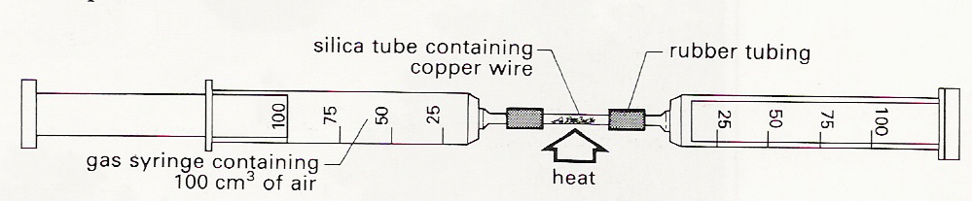

The one on the left starts with (say) 120 cm³ of air. The copper wire is heated, and the air is shunted back and forth through the combustion tube. The oxygen reacts with the copper:
2Cu + O₂ → 2CuO

When the apparatus has cooled back to room temperature the final volume of the gas is (say) 95 cm³, so the proportion of oxygen is 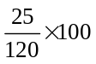= 21%.
(Similar experiments can also be done with Phosphorus or Iron in place of the copper).

Preparation of Oxygen
Oxygen is prepared industrially by the fractional distillation of liquid air.
Water and CO₂ are removed to avoid blocking the tubes, then air is cooled to –200ºC and fractionally distilled.
Nitrogen boils off first at –196ºC, followed by argon at –186ºC, then oxygen at –183ºC.

In the laboratory oxygen is preparation from hydrogen peroxide.
2H₂O₂ → O₂ + 2H₂O
MnO₂ is added as a catalyst and the oxygen is collected by downward displacement of water.

Uses of Oxygen
Oxygen is used in steel manufacture (removal of carbon from molten iron), welding and
cutting (e.g. oxy-acetylene torch), and breathing apparatus (e.g. subaqua).

Oxidation and Redox
The term oxidation is refers to include gain of oxygen by a molecule.
Reduction is defined as the reverse of oxidation: loss of oxygen.

Oxidation and reduction always occur together in a chemical reaction: if one substance is
oxidised, another must be reduced. Reactions involving oxidation and reduction are called
redox reactions.

Reactions of Oxygen
Reactions of with metals.
- Metals react with oxygen to form alkaline metal oxides.
2Ca + O₂ → 2CaO(s) Calcium oxide – used to neutralise acidic soils.
Reactions of with non-metals.
- Non-metals react with oxygen to form acidic non-metal oxides.
C + O₂ → CO₂(g)
Carbon dioxide used in carbonating drinks and in fire extinguishers.
Reactions of with hydrocarbons.
- Hydrocarbons undergo complete and incomplete combustion when reacted with oxygen.
C₃H_{8(g)} + 5O_{2(g)} → 3CO_{2(g)} + 4H₂O_{(l)}

Carbon Dioxide
Carbon dioxide is a colourless gas which is more dense than air. It is a very important gas as it is responsible for acid rain, the greenhouse effect and photosynthesis in plants.

Laboratory Preparation of Carbon Dioxide

Dilute hydrochloric acid is reacted with calcium carbonate.
2HCl_{(aq)} + CaCO_{3(s)} → CaCl_{2(aq)} + H2O_{(l)} + CO2_{(g)}
If necessary the carbon dioxide gas can be dried by passing it through concentrated H₂SO₄.
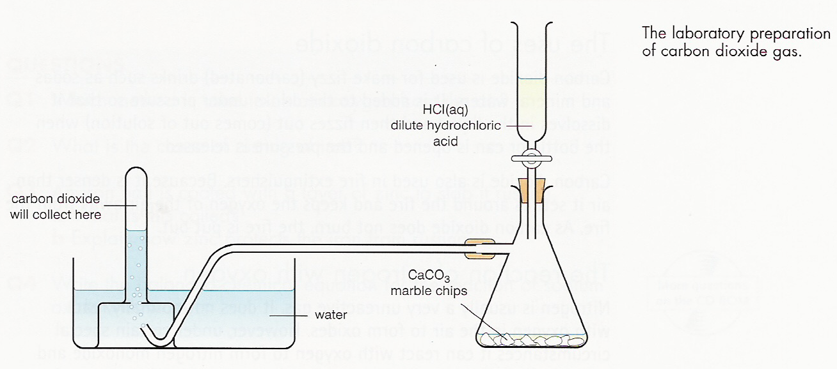

Reactions of Carbon dioxide
Carbon dioxide reacts with water to form carbonic acid (acid rain).
CO_{2(g)} + H2O_{(l)} H2CO_{3(aq)}

Being a non-metal oxide carbon dioxide is acidic and so it reacts with alkalis to make salts (called carbonates). CO_{2(g)} + Ca(OH)_{2(aq)} → CaCO_{3(s)} + H2O_{(l)}
Ca(OH)₂ is commonly known as limewater. A cloudy precipitate of calcium carbonate is produced. This reaction is the test for carbon dioxide

Uses of carbon dioxide
Carbon dioxide is used in carbonated drinks (as it is only soluble in water when under pressure). Fire extinguishers (as it is non flammable). It is also used in its solid form ‘dry ice’ in theatres. (as it is very cold and sublimes).
Other Oxides
Sulphur dioxide
Pollutant formed from the combustion of sulphur impurities in Coal and petrol
Reaction with water SO₂ + H₂O → H₂SO₃ (Sulphurous acid – Acid rain)

Nitrogen Dioxide – NO₂
Formed in the internal combustion engine – from the combustion of nitrogen in air.
Causes acid rain and photochemical smog.

Hydrogen
Hydrogen: this is a unique element, since it has an atom with only one electron.
It is a non-metal, forms H2 molecules, and is a gas at room temperature.
It has an unusual position in the periodic table as it is sometimes placed above Lithium in group 1. This is because although it is a non-metals it has one electron in its outer shell and so, like the alkalia metals, it can form ions with a charge of +1 (valency 1).

Laboratory preparation of hydrogen
Hydrogen is made by reacting zinc with dilute sulphuric acid and collected by upward delivery.
If dry hydrogen is needed, the gas is passed through a drying agent, silica gel or conc H₂SO₄

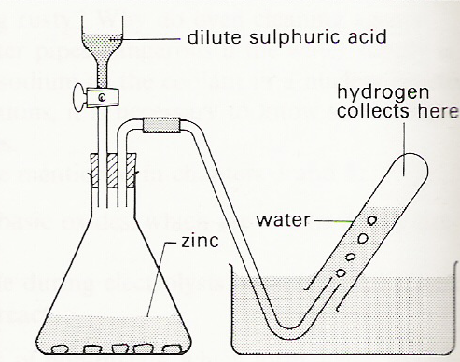

Combustion of Hydrogen
Combustion of hydrogen with air or oxygen produces water as the only product.
2H₂(g) + O₂(g) → 2H₂O(l)

The reaction also gives out useful energy and hydrogen is often refered to as ‘the fuel of the future’ as water is the only combustion product.

Test for water
There are a number of tests for the presence of water.

- Cobalt chloride paper Turns from Blue to Pink.
- Anhydrous copper(II) sulphate Turns from White to Blue.

The test for pure water is – Boils at 100ºC and freezes at 0ºC.
The Reactivity Series

K Na Li Ca Mg Al* [C] Zn Fe [H] Cu
(* Al is protected by a coating of aluminium oxide, which makes it seem less reactive than it really is).

Evidence about the reactivity of metals can be gained from how vigorously they react with water or acids.

With water - The most reactive metals react violently with cold water: potassium melts, fizzes around the surface, catches fire and burns with a lilac flame; sodium melts to a silver ball, fizzes around the surface, giving hydrogen; calcium reacts by fizzing vigorously:
2K + 2H₂O → 2KOH + H₂
2Na + 2H₂O → 2NaOH + H₂
Ca + 2H₂O → Ca(OH)₂ + H₂

The other metals above hydrogen in the series react with steam, to form the metal oxide and hydrogen:
Zn + H₂O → ZnO + H₂

With acids - Metals above hydrogen will react to form metal salts and hydrogen.
Mg + 2HCl → MgCl₂ + H₂

Competition and Displacement reactions
It is often more reliable to compare the reactivity of metals directly.
There are two types of reaction which are suitable: competition and displacement.

In competition reactions one metal is heated with the oxide of another, to see if it can take the oxygen away (or “reduce” the second metal).
e.g. Magnesium, when heated with copper(II) oxide, gives out much heat and forms copper metal:
Mg(s) + CuO(s) → MgO(s) + Cu(s)

This shows that magnesium is more reactive than copper. Clearly, if we tried heating copper and magnesium oxide, the reaction would not work.

The two non-metals carbon and hydrogen are also reducing agents, and competition reactions can be used to put them into the reactivity series, even though they are not like metals in other respects.

In displacement reactions a metal is dipped into a solution of the salt of a second metal. If the first metal is able to displace the second, it is more reactive. We need to study the surface of the metal for a change in appearance to decide if the second metal is being deposited (not always easy if both metals are silvery-grey).
e.g. Iron wire dipped into copper sulphate solution becomes coated in reddish copper, while the blue colour fades, so iron is more reactive:
Fe(s) + CuSO₄(aq) → FeSO₄(aq) + Cu(s)
blue solution pink/red coating

Redox reactions

The process of changing copper into copper oxide is called an oxidation. As far as the copper atoms are concerned, the process involves removing two electrons, to form copper ions: Cu → Cu²⁺ + 2e–

The term oxidation is extended to include gain of oxygen or removal of electrons: in some circumstances it can also involve removal of hydrogen from a molecule. In electrolysis, the process which occurs at the anode always involves removal of electrons, and so is an oxidation.

Reduction is defined as the reverse of oxidation: loss of oxygen, gain of electrons or gain of hydrogen. In electrolysis the cathode process involves positive ions gaining electrons, and so is a reduction.

Oxidation and reduction always occur together in a chemical reaction: if one substance is oxidised, another must be reduced. Reactions involving oxidation and reduction are called redox reactions.

In the examples below the underlined atom is being oxidised, while the one with a double underline is being reduced:

2 Cu + O₂ → 2CuO (e.g. on heating copper in air)
Zn + CuSO₄ → ZnSO₄ + Cu (displacement reaction)
Mg + 2HCl → MgCl₂ + H₂ (reactive metal + acid)
2 NaBr + Cl₂ → 2NaCl + Br₂ (chlorine displaces less reactive Br)
Fe₂O₃ + 3CO → 2Fe + 3CO₂ (blast furnace)
2FeCl₂ + Cl₂ → 2FeCl₃ (chlorine oxidises iron(II) )

Note that redox reactions generally involve changing between an element and its compound, or changing the valency of an atom.

An oxidising agent is a substance which causes another to be oxidised (and so is itself reduced) e.g. in the last equation Cl₂ is the oxidising agent and FeCl₂is the reducing agent.

N.B. a precipitation reaction like the chloride test:
NaCl(aq) + AgNO₃(aq) → NaNO₃(aq) + AgCl(s) is not a redox process.

Redox reactions involving ions are electron transfer processes: the atom which loses electrons is being oxidised, while the atom which gains is being reduced.

For the reactions above, we can show the separate processes as HALF EQUATIONS:

Cu → Cu²⁺ + 2e– (Cu oxidised) and O₂ + 4e– →2O^{2–}(O₂ reduced)
Zn → Zn²⁺ + 2e– and Cu²⁺ + 2e– → Cu
Mg → Mg²⁺ + 2e– and 2H⁺ + 2e– → H₂
2Br– → Br₂ + 2e– and Cl₂ + 2e– → 2Cl–
2CO + O^{2–} → CO₂ + 2e– and Fe³⁺ + 3e– → Fe
Fe²⁺ → Fe³⁺ + e– and Fe³⁺ + e– → Fe²⁺
The Reactivity Series
You need to be able to interpret the results of reactivity series experiments rather than to learn a table, but for reference the order of the common metals (most reactive first) is:

K Na Ca Mg Al* [C] Zn Fe Pb [H] Cu Ag

Al is protected by a coating of aluminium oxide, which makes it seem less reactive than it really is.

Carbon will reduce the oxides of the less reactive metals, up to zinc, so is placed above zinc. Hydrogen will reduce copper oxide, but also oxides of lead and iron if heated strongly enough; however, it is placed below Fe and Pb because they will displace it from acids.

Extraction of metals
Only the least reactive of metals (e.g. gold) are found uncombined in their native form. The majority are found as compounds, only some of which are suitable sources for extracting the metal.

An ore is a body of rock which contains minerals (metal compounds), or more rarely uncombined metals, in sufficient quantity for it to be economic to extract the metal.

The compounds from which metals are extracted are usually oxides. In some cases the minerals need to be roasted in air to be converted into the metal oxides.

For metals up to zinc in the reactivity series, the most common method of extraction is by heating the oxide with carbon or carbon monoxide. Carbon is plentiful and cheap, in the form of coke or charcoal, and it forms a gaseous product (carbon dioxide) which is easy to remove. We shall illustrate this method with the blast furnace (next section).

Metals above zinc are too reactive for their oxides to be reduced by carbon, and must be extracted by electrolysis, which is a more expensive method.

Extraction using metal displacement reactions

The Thermite Reaction (Extraction of Iron)
Iron can be extracted from iron(II) oxide using a potentially explosive mixture called Thermite. The reaction is only performed on a small scale and is still used today to weld railway tracks together.

In the reaction Aluminium metal is used to Displace iron from iron(III) oxide. The heat generated from the reaction is enough to melt the iron.
Fe₂O₃ + 2Al → 2Fe + Al₂O₃
The molten iron can then be placed between the railway tracks and when it cools and solidifies the tracks will be joined.
Extraction using Carbon Reduction - Iron

The Blast Furnace
limestone
waste gases
iron ore and coke
Iron(III) oxide (haematite) is mixed with coke (almost pure carbon obtained by heating coal in the absence of air) and limestone (calcium carbonate). These enter the blast furnace from the top, and hot air is blown in at the bottom. Some of the carbon is oxidised, giving out much heat and taking the temperature up to 1200oC
3
2C + O₂ → 2CO (at 1 in the diagram)
Iron ore is reduced by both CO and C:
2
Fe₂O₃ + 3CO → 2Fe + 3CO₂
Fe₂O₃ + 3C → 2Fe + 3CO (at 3)
hot air
1
Slag formation occurs at 2:
hot air
CaCO₃ → CaO + CO₂
molten iron
molten slag
CaO + SiO₂ → CaSiO₃ (molten slag)

The molten iron runs to the bottom of the furnace, where it is tapped off from time to time.

The limestone decomposes as shown, to give calcium oxide, and this reacts with impurities such as silicates to produce a molten slag, which floats on top of the iron and is itself removed periodically.

Rusting of Iron

Most metals tend to oxidise slowly if left out in the air, especially if the air is wet and if it contains salt. This type of corrosion is most important for iron and steels, when it is known as rusting. Rust is iron(III) oxide, Fe₂O₃.

Rusting can only occur if iron comes into contact with both air and water. It occurs more rapidly near the sea, and in winter when salt is put on the roads, because salt (sodium chloride) speeds up the reaction.

We usually try to prevent rusting by keeping out both air and water. Various methods are possible:
- Painting: this is cheap, and covers the surface. But the paint may chip, and once surface is exposed rusting begins.

- Coating with zinc: (galvanising). This involves dipping the steel object into molten zinc. It forms a tougher coating than paint, and once scratched rusting is slow, because the zinc is more reactive than iron and oxidises in preference (a form of sacrificial protection). Used in corrugated iron, galvanised buckets etc.

- Sacrificial protection: fastening blocks of a more reactive metal such as magnesium to the steel, at intervals (e.g. to a steel mast on a yacht). The more reactive metal oxidises in preference to the iron – i.e. is sacrificed – and can be replaced.
Extracting Metals using Electrolysis

Electrolysis is the passage of electricity through a liquid accompanied by a chemical change taking place at the electrodes
.
The electrodes are the conductors (made of metal or graphite) by which the current enters or leaves the electrolyte. The electrode connected to the positive battery terminal is known as the anode; the electrode connected to the negative battery terminal is known as the cathode. The substance which is split up by electrolysis (when molten or in aqueous solution) is known as the electrolyte.

For a liquid electrolyte to be able to conduct electricity, it must contain electrically charged particles called ions.
The ions must be free to move, which is why electrolysis can’t take place in solids.
Ions that move towards the cathode (negative electrode) are called cations: they carry a positive charge. Ions that move towards the anode (positive electrode) are called anions: they carry a negative charge.

When a positive ion reaches the cathode, it accepts enough electrons to make it neutral:
Na⁺ + e– → Na(l); Al³⁺ + 3e– → Al(l)

At the anode, negative ions give up their extra electrons. Once neutral, they react to form stable molecules:
e.g. Br– → Br + e– then 2Br → Br₂(l)
overall: 2Br– → Br₂(l) + 2e–

Metals and hydrogen form positive ions, and are set free at the cathode.

Non-metals ( except hydrogen ) form negative ions and are set free at the anode.

Aluminium Extraction
Most of the more reactive metals are extracted by electrolysing their molten chlorides. However, aluminium is extracted from bauxite, which is mainly Al₂O₃. This is purified using sodium hydroxide.

Aluminium oxide is not soluble in water, and its melting point is very high (2040ºC).
For electrolysis it has to be dissolved in a molten salt called cryolite (formula Na₃AlF₆) at 900ºC.

At the cathode, aluminium ions each accept three electrons to change them to neutral aluminium atoms:
Al³⁺ + 3e– → Al_{(l)}

At the anode, oxide ions each give up two electrons to form oxygen atoms. These combine in pairs to form oxygen molecules.

In practice, a carbon anode is used, and the oxygen reacts with the carbon to form carbon dioxide.
2O^{2–} → O₂ + 4e–

then: C + O₂ → CO₂

Overall 2Al₂O₃ → 4Al + 3O₂

Aluminium will not corrode due to the protective layer of Al₂O₃.
Electrolysis

General Electrolysis
For a liquid electrolyte to be able to conduct electricity, it must contain electrically charged particles called ions. The ions must be free to move, which is why electrolysis can’t take place in solids.

When a positive ion reaches the cathode, it accepts enough electrons to make it neutral:
Na⁺ + e– → Na(l); Al³⁺ + 3e– → Al(l) REDUCTIONS
At the anode, negative ions give up their extra electrons. Once neutral, they react to form the most stable molecule:
e.g. Br– → Br + e– then 2Br → Br₂(l)
overall: 2Br– → Br₂(l) + 2e– OXIDATION

Metals and hydrogen form positive ions, and are set free at the cathode.
Non-metals ( except hydrogen ) form negative ions and are set free at the anode.

Rules of Electrolysis
Molten salts
Electrolysis of molten salts is straightforward, since there is only one type of each ion present, and these are discharged.
e.g. molten sodium chloride:
cathode: Na⁺ + e– → Na(l) Note that 2Na are
anode: 2Cl– → Cl₂(g) + 2e– produced for each Cl₂

Aqueous solutions
Aqueous solutions contain H⁺ and OH– ions from the water in addition to the ions from the solute dissolved in water.
For example, an aqueous solution of sodium chloride contains Na⁺, Cl–, H⁺ and OH– ions. There are rules which help to predict what will happen at the electrodes.

Rules for aqueous solutions
At the cathode:
- If the solute contains the ions of a metal high in the reactivity series (e.g. Na, Mg) or hydrogen ions from an acid, then hydrogen will be liberated.
- If the solute contains the ions of a metal low in the reactivity series (e.g. Cu, Pb ) then the metal will be liberated.
- In a choice between two ions, the one lower in the reactivity series will normally be discharged (e.g. from H⁺, Cu²⁺ and Ag⁺, Ag will be formed).

At the anode:
- If the solute is a concentrated solution of a chloride, then chlorine will be liberated. This also applies to bromides (giving bromine) and iodides (giving iodine), though for these the solution need not be concentrated.
- If the solute is a dilute solution of a chloride, or does not contain a chloride (e.g. it is a sulphate, nitrate or hydroxide), then oxygen will be liberated from OH–
4OH– → 2H₂O(l) + O₂(g) + 4e–

Examples
Dilute aqueous sulphuric acid - Gives hydrogen and oxygen gases in a 2:1 ratio by volume.
The solution becomes more concentrated as (in effect) water is removed.
Cathode: only H⁺(aq) present 2H⁺(aq) + 2e– → H₂(g)
Anode: OH– and SO₄^{2–} present. Easier to discharge hydroxide:
4OH– → 2H₂O(l) + O₂(g) + 4e–

Aqueous copper(II) sulphate - Cu is deposited at the cathode, and O₂ is given off at the anode.
Cathode: Cu²⁺ and H⁺(aq) present. Cu²⁺ is discharged, since Cu is less reactive than H.
Cu²⁺(aq) + 2e– → Cu(s)
Anode: OH– and SO₄^{2–} present. Easier to discharge hydroxide:
4OH– → 2H₂O(l) + O₂(g) + 4e–

Electrolysis of Brine – Sodium Chloride Solution
Brine is an aqueous solution of sodium chloride. It therefore contains Na⁺ and Cl– ions from the sodium chloride and H⁺ and OH– ions from the water.

At the cathode: Na⁺ and H⁺(aq) present. H⁺(aq) is discharged, since H is below Na in reactivity.
2H⁺(aq) + 2e– → H₂(g)
At the anode: OH– and Cl– present. Cl– is discharged, since it is in high concentration.
2Cl⁻(aq) à Cl₂(g) + 2e⁻
Note – We can test for chlorine produced using its ability to bleach indicator paper.

Therefore the electrolysis of brine gives hydrogen and chlorine gases, leaving sodium hydroxide behind (this is how NaOH and Cl₂ are made in the chloralkali industry).

Membrane cells
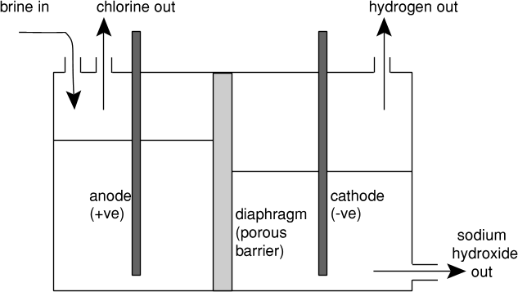
The cathode is shielded by an ion-exchange membrane. The membrane only allows sodium ions (not Cl– or OH–) to pass through. There is therefore no contact between the chlorine gas and the sodium hydroxide. If they did react they would form bleach (NaClO).

Uses of the products
- Sodium hydroxide, NaOH is used as an oven cleaner, to make soap, to make bleach, and to purify aluminium oxide in aluminium extraction.
- Chlorine as a bleach (and to make household bleach, a solution of sodium chlorate(I), NaClO), to purify drinking water (by killing bacteria), to purify swimming pools (also by killing bacteria).
- Hydrogen is used as a fuel and to hydrogenate oils in the manufacture of margarine.
Calculations involving electrolysis
The amount of a substance produced in electrolysis depends on the quantity of electricity passed, and this is measured by the charge passed.

The total charge which passes during electrolysis can be worked out used the equation:
Charge (Coulombs) = current (Ampères) × time (seconds)

The charge on one mole of electrons is called the Faraday. It has a value of about 96000 C/mol.

The amount of a product produced depends on the charge on the ions involved.
Equation | r.a.m. | 1 mole | Charge needed (C)
Na⁺ + e– → Na(l); | Na=23 | 23g Na | 96 000
Cu²⁺(aq) + 2e– → Cu(s) | Cu=64 | 64g Cu | 192 000
Al³⁺ + 3e– → Al(l) | Al=27 | 27g Al | 288 000
2Cl– → Cl₂(g) + 2e– | Cl=35.5 | 71g Cl₂ | 192 000
4OH– → 2H₂O(l) + O₂(g) + 4e– | O=16 | 32g O₂ | 384 000

To find the mass of metal deposited.
e.g. What mass of aluminium will be deposited if a current of 1.5 A is passed through aluminium oxide (dissolved in molten cryolite) for 40 minutes?
[Data: Al = 27; 1 Faraday = 96000 C mol^{–1}]

1. Find the total charge passed
Charge passed = 1.5 A × 40 × 60 s = 3600 C

2. Convert this to moles of electrons (divide by the Faraday)
number of moles of electrons = 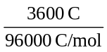 = 0.0375 mol

3. Write out ion-electron equation and deduce number of moles of substance per mole of electrons
Equation is: Al³⁺ + 3e– → Al So 1 mol of electrons deposits ⅓ mol of Al atoms

4. Convert moles of electrons passed into mass of product
So 0.0375 mol of electrons deposit ⅓ × 0.0375 = 0.0125 mol Al
So mass of Al produced = moles x molar mass = 0.0125 × 27 = 0.338 g

Note – If you are told the number of faradays involved you know the moles of electrons so you can start at step 3.

e.g. What mass of magnesium will be deposited if 5 faradays pass through molten magnesium chloride?

5 faradays = 5 moles of electrons

Starting at step 3 we write out ion-electron equation and deduce number of moles of substance formed from 5 moles of electrons.

Equation is: Mg²⁺ + 2e– → Mg So 2 mol of electrons deposits 1 mol of Mg atoms
5 moles of electrons deposits 5/2 moles of Mg atoms = 2.5 moles = 2.5 x 24 = 60 g.
Industrial Uses of Electrolysis

Electrolysis is used for;
- The extraction of reactive metals (those more reactive than zinc).

- The purification of metals, especially copper.

- The chloro-alkali industry. Electrolysis of brine to obtain NaOH, Cl₂ and H₂.

- The production of hydrogen.
Hydrogen is potentially a non-polluting fuel. At present it is expensive to make hydrogen by electrolysis. However, if we can develop solar powered cells further, we may be able to use the energy from the sun to give us electricity. This electricity cannot be stored directly, but could be used to electrolyse dilute sulphuric acid. The hydrogen and oxygen obtained could be stored, and then reacted to drive engines, or generators, or used in fuel cells to give electrical energy again.
Energetics

An exothermic change is one in which heat is given out to the surroundings. e.g. burning a fuel.
An endothermic change is one in which heat is absorbed from the surroundings. If an endothermic change occurs in a beaker (or calorimeter), the temperature of the vessel and its contents will fall.

An Enthalpy change (ΔH) is defined as: An energy change in a reaction that takes place at constant pressure.

Enthalpy profile diagrams
The enthalpy changes during a reaction can be plotted on an enthalpy profile diagram.

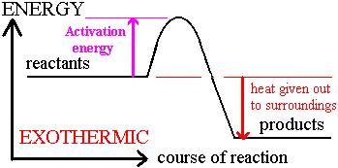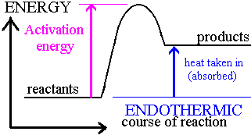

- A reaction in which the products have less energy than the reactants is exothermic.
- A reaction in which the products have more energy than the reactants is endothermic.
- The difference between the reactants and the products is the enthalpy change for the reaction.
- The difference in energy between the reactants and the point of maximum energy achieved during the reaction is called the activation energy.

Calculating the energy released by a fuel
We can find the energy released by a fuels in the laboratory by using them to heat up water in a copper can.

The following measurements are needed:
- mass of fuel used (so weigh it before and after)
- the amount of water (best to use the same mass or volume each time)
- the temperature rise (so take initial and final temperatures)

It is known that 4.2 Joules are needed to warm 1.0 g of water by 1.0ºC. This is known as the specific heat capacity of water.

Therefore: To calculate the energy liberated by a fuel;
E (J) = mass of water (g) × 4.2 J/(ºC g) × temp rise (ºC)

The energy released per mole of fuel can then be calculated using the mass of fuel used.

E is divided by the moles of fuel used to obtain the energy liberated per mole ΔH (or enthalpy). (This is expressed in kJ/mol).
Example calculation.
50cm³ of HCl is placed in a polystyrene cup. 50cm³ of NaOH solution is placed in a beaker. The temperature of each is 18ºC. The NaOH solution is then added to the HCl in the cup. The temperature increases to 24ºC. (Moles HCl = Moles NaOH = 0.05 mol)
Calculate the enthalpy change for this reaction.

Note - Mass of water = total volume of the solution = 50cm³ + 50cm³ = 100 cm³

E (J) = mass of water (g) × 4.2 J/(ºC g) × temp rise (ºC)
= 100 x 4.2 x (18 – 24) = -2520 J

Moles HCl = Moles NaOH = 0.05 mol

∆H^{θ} = -2520 / 0.05 = -50,400 J mol⁻¹ or – 50.4 kJ mol⁻¹ (3 sig fig)

Energy and bonds
Energy is given out when a new bond is formed and energy must be supplied in order to break a bond.
A chemical change will be exothermic if less energy is needed to break the old bonds than is given out when the new ones are formed.

An example is the reaction between hydrogen and chlorine molecules:
H₂ + Cl₂ → 2 HCl
or, showing the bonds: H—H + Cl—Cl → 2 H—Cl

Energy must be put in to break H—H and Cl—Cl,
but formation of two H—Cl bonds gives out more energy than this, so overall the reaction gives out heat.

Bond energies are measured in kJ/mol, e.g. H—H 436; Cl—Cl 242; H—Cl 431 kJ/mol

ΔH = + energy to break bonds – energy when new bonds made
= + ( H—H + Cl—Cl ) – ( 2 × H—Cl)
= + ( 436 + 242 ) – ( 2 × 431 )
= + 678 – 862
= – 184 kJ/mol (negative sign means 184 kJ given out when 2 mol of HCl are formed)

We can show this on an energy diagram which represents the heat energy content of the molecules. 678kJ/mol is put in to split the H—H and the Cl—Cl up into atoms, and then 862 kJ/mol is given out when the two new H—Cl bonds are formed:

2H + 2Cl
atoms
heat energy
content
Final level is below level on left, since reaction gives out heat — i.e. the heat content of the compound is less
+678
–862
H—H +
Cl—Cl
before
–184 kJ/mol
net change
2 H—Cl
after

progress of reaction

e.g. Use the bond energies given to find the energy released when one mole of methane is burnt:
CH₄ + 2O₂ → CO₂ + 2H₂O

Data: C—H 413; O=O 497; C=O 803; H—O 463 kJ/mol

Rewrite the equation showing all the bonds:
H
O=O
O=O
H–O–H
H–O–H
H—C—H + → O=C=O +
H

ΔH = + energy to break bonds – energy when new bonds made
= + ( 4 C—H + 2 O=O) – ( 2C=O + 4 H—O )
= + (4 × 413 + 2 × 497) – ( 2 × 803 + 4 × 463)
= – 812 kJ/mol (i.e. 812 kJ released for each mole of methane)

We can use bond energies to predict the amount of energy which will be given out when we burn any particular alkane or alcohol, and so can compare their effectiveness as fuels.

Average bond dissociation energies

The bond energies used to calculate enthalpy changes are average values obtained from a wide array of compounds.

They may not be the exact values for the compounds in any particular example.

For this reason enthalpy changes calculated using bond dissociation energies only give a rough value of the enthalpy change for the desired reaction.
Acids, Bases, Salts and Neutralisation

pH and Indicators
The pH scale measures the acidity of solutions of substances dissolved in water.
A pH of 7 is neutral: pHs below 7 are acidic — the lower the pH, the stronger the acid.
pHs above 7, up to 14, are alkaline. For example, ammonia solution is a weak alkali (pH about 11) while sodium hydroxide is a strong alkali (pH about 14).

We can use universal indicator to measure pH: the colours vary slightly, but one sort changes as follows: pH = 1 3 7 10 14
colour red yellow green blue purple
(pH can also be measured using a “pH meter”).

Other indicators can be used to test if a substance is acidic or alkaline.
Indicator | Colour in acid | Colour in alkali
LITMUS | RED | BLUE
METHYL ORANGE | ORANGE | YELLOW
PHENOL PHTHALEIN | COLOURLESS | PINK

Acids
An Acid can be defined as a substance containing a hydrogen atom which can be replaced by a metal, and giving a pH of less than 7 when dissolved in water.

Examples: Formula Acid Salts formed Formulae of salts
HCl hydrochloric chlorides NaCl, MgCl₂
H₂SO₄ sulphuric sulphates Na₂SO₄, MgSO₄
HNO₃ nitric nitrates NaNO₃, Mg(NO₃)₂

Reactions of Acids
Acids react with metals above H in the reactivity series (e.g. magnesium and zinc) to give hydrogen.

reactive metal + acid → metal salt + hydrogen
Mg(s) + 2HCl(aq) → MgCl₂(aq) + H₂(g)
Zn(s) + H₂SO₄(aq) → ZnSO₄(aq) + H₂(g)

Acids react with bases (normally metal oxides or hydroxides) to form a salt and water only.
Note: soluble bases are called alkalis (e.g. sodium hydroxide, potassium hydroxide):

base (alkali) + acid → metal salt + water
CuO(s) + 2HNO₃(aq) → Cu(NO₃)₂(aq) + H₂O(l)
NaOH(aq) + HCl(aq) → NaCl(aq) + H₂O(l)

Acids react with metal carbonates at room temperature, to fizz and give off carbon dioxide.

metal carbonate + acid → metal salt + water + carbon dioxide
CaCO₃(s) + 2HCl(aq) → CaCl₂(aq) + H₂O(l) + CO₂(g)
Acids and Ions
Acids must be dissolved in water before they can act as acids. For example, the gas hydrogen chloride (HCl) will dissolve in methylbenzene, and the resulting solution will not react with magnesium.

Water is necessary because the acid reacts with water to form ions (charged atoms or molecules), including the hydroxonium ion, H₃O⁺ [often written as H⁺(aq), and called hydrogen ions]:
HCl(g) + H₂O(l) H₃O⁺(aq) + Cl–(aq)

Pure water contains equal (but very small) amounts of hydroxonium and hydroxide ions:
2H₂O(l) H₃O⁺(aq) + OH–(aq)
It is often easier to write this in the simpler form:
H₂O(l) H⁺(aq) + OH–(aq)

A solution is neutral if it has equal amounts of H⁺(aq) and OH–(aq). If it has more H⁺(aq) it is acidic, while if it has more OH–(aq) it is alkaline.

An alternative, and more modern, definition of an acid is a substance which will form hydrogen ions when dissolved in water.

This is the Arrhenius Definition of acids – A substance that contains H⁺ ions in water.
e.g. hydrochloric acid: HCl(g) + water → H⁺(aq) + Cl–(aq)

Alkalis and Ions
Alkalis are substances which increase the concentration of hydroxide ions, when dissolved in water. (This is the Arrhenius definition of an alkali).

Soluble metal hydroxides like NaOH and KOH are strong alkalis, since they give high concentrations of hydroxide ions (pHs around 14, depending on how much is dissolved).
Calcium hydroxide is not very soluble, and so its solutions have lower pHs (e.g. 11 in limewater).

Ammonia solutions are weakly alkaline, because of the reaction:
NH₃ + H₂O NH₄⁺ + OH–

Brønsted-Lowry Acid / Base Theory
Brønsted-Lowry theory of acids and bases states that;
An acid is a proton (H⁺) donor and a base is a proton (H⁺) acceptor.

e.g. When HCl gas is added to water a reaction occurs:
HCl + H₂O H₃O⁺ + Cl–

In this process the HCl donates a proton(H⁺) to the water, so HCl is the acid.
Water has accepted a proton (H⁺) so water is the base.

Neutralisation
Neutralisation is the reaction between an acid and a base to form a salt and water only.

When the acid reacts with an alkali (soluble base), the ionic equation is always:
H⁺(aq) + OH–(aq) → H₂O(l)
Ionic equations
When ionic salts dissolve in water the ions move around separately, each surrounded by water molecules.

Any particular ion does not ‘remember’ which salt it came from, so mixing equal amounts of NaCl and KBr in 1 dm³ of water would give the same result as mixing equal amounts of NaBr and KCl in 1 dm³ of water i.e. equal amounts of Na⁺(aq), K⁺(aq), Cl–(aq), and Br–(aq).

If two of the ions happen to react, the other ions play no part - these are called “spectator ions”.

When we write an ionic equation, we include all ions or molecules which change in state or react, but miss out all spectator ions.

It is essential to include a state symbol for each ion.

e.g. when barium nitrate solution reacts with sodium sulphate solution, a white precipitate of barium sulphate is formed:

Ba(NO₃)₂(aq) + Na₂SO₄(aq) → BaSO₄(s) + 2NaNO₃(aq)

If we show all the ions and their states, we can see which ones are spectators (underlined):

Ba²⁺(aq)+2NO₃–(aq)+2Na⁺(aq)+SO₄^{2–}(aq) → BaSO₄(s) + 2Na⁺(aq) + 2NO₃–(aq)

If we leave these out, the ionic equation becomes simply:
Ba²⁺(aq) + SO₄^{2–}(aq) → BaSO₄(s)

Some guidance to ionic equations:
- always include state symbols and omit spectator ions.

- dissolved metal compounds are always ionic: MgCl₂(aq) is Mg²⁺(aq) + 2Cl–(aq);

- common negative ions include: NO₃–, Cl–, OH–, SO₄^{2–}, CO₃^{2–}.

- strong acids [HCl(aq), HNO₃(aq) and H₂SO₄(aq)] are ionic: e.g. 2H⁺(aq)+SO₄^{2–}(aq)

- solid compounds, pure liquids or gases are not written as ions: AgCl(s), H₂O(l), CO₂(g).
Moles and Solutions - Concentration

When a substance is dissolved in water, its concentration is given by:

concentration (mol/dm³) = 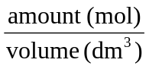
1

The concentration of a substance in mol/dm³ is called the molarity of the solution.
1.0 dm³ is 1000 cm³, so volume (dm³) = 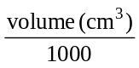; hence 200 cm³ is 0.20 dm³, and
50 cm³ is 0.050 dm³. You may also come across values in Litres: 1.0 L = 1.0 dm³.

The main equation can be rearranged as:
2
amount (mol) = volume (dm³) × concentration (mol/dm³)

or volume (dm³) = 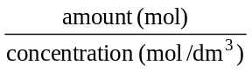
3
2
1
Equation is probably the most useful one to learn, although is easiest, since it follows from the units.

The same general calculation method as in T3 can be used.

The steps involved are as follows :

(a) Convert the information given to moles of one substance.

(b) Use the chemical equation to find moles of other substance needed.

(c) Convert back from moles to mass (or concentration, volume etc.)

e.g. An antacid tablet contains 0.330 g of calcium carbonate. If a sample of stomach acid contains 0.0600 mol/dm³ of hydrochloric acid, what volume of the acid could be neutralised by the tablet?
The equation is: CaCO₃ + 2 HCl → CaCl₂ + 2H₂O

(a) Molar mass of CaCO₃ = 40 + 12+ 3 × 16 = 100 g/mol
Amount of CaCO₃ in one tablet = 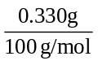 = 0.00330 mol

(b) From equation 1 mol CaCO₃ reacts with 2 mol HCl
So 0.00330 mol CaCO₃ reacts with 2 × 0.00320 = 0.00660 mol HCl.

(c) volume (dm³) = 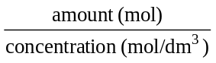= 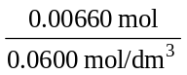 = 0.110 dm³
So volume = 0.110 dm³, or 110 cm³ of stomach acid.
e.g. 62.0 cm³ of stomach acid containing hydrochloric acid is neutralised by one 290 mg tablet of magnesium hydroxide. Calculate the concentration of the stomach acid.

The equation is: Mg(OH)₂ + 2 HCl → MgCl₂ + 2 H₂O

(a) Molar mass of Mg(OH)₂ = 24 + 2 × (16 + 1) = 58 g/mol

Mass of Mg(OH)₂ in one tablet = 290 mg = 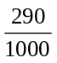g = 0.290 g

Amount of Mg(OH)₂ in one tablet = 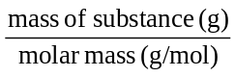
= 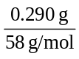 = 0.00500 mol

- From equation one mol Mg(OH)₂ reacts with 2 mol HCl

So 0.00500 mol Mg(OH)₂ reacts with 2 × 0.00500 = 0.0100 mol HCl

(c) Volume of acid used = 62.0 cm³ = 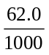dm³ = 0.062 dm³
concentration of acid (mol dm–3) = 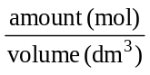 = 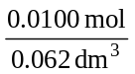
= 0.161 mol/dm³

Titrations

Technique used to find the concentration of acids and to make soluble salts from an acid and an alkali.

e.g. finding the concentration of ethanoic acid in a sample of vinegar.

- A pipette is used to measure exactly 20.0 cm3 of the ethanoic acid, and this is transferred to a conical flask.
- 2-3 drops of phenolphthalein are added as indicator: it remains colourless.
- A burette is filled with sodium hydroxide of known concentration.
- The initial volume is read, then the tap is opened to add NaOH, rapidly at first, but dropwise near the end-point (when the colour of the indicator takes time to fade) until there is a permanent pink colour.
- The difference between the initial and final volume readings gives the volume added.
- The whole experiment should be repeated, to obtain an average value for the volume of NaOH needed — called the titre.

Titration Calculations
Use the same general method above.

e.g. If 20.0 cm³ of vinegar takes a titre of 21.6 cm³ of 0.100 mol/dm³ sodium hydroxide solution, find the concentration of ethanoic acid.

Equation is: CH₃CO₂H + NaOH → CH₃CO₂Na + H₂O

(a) Amount of NaOH (mol) = concentration (mol/dm³) × volume (dm³)
= 0.100 mol/dm³ × 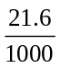dm³
= 0.00216 mol

(b) From equation, 1 mol NaOH reacts with 1 mol CH₃CO₂H

So 0.00216 mol NaOH react with 0.00216 mol CH₃CO₂H

(c) concentration of acid (mol/dm3) =
=
= 0.108 mol/dm³

e.g. A sample of rust remover contains orthophosphoric acid, H₃PO₄. When 10.0 cm³ of rust remover is titrated with 2.0 mol dm^{–3} sodium hydroxide, 16.0 cm³ of alkali is required. Calculate the concentration of orthophosphoric acid (a) in mol/dm³; (b) in g/dm³.

The equation is: H₃PO₄ + 3 NaOH → Na₃PO₄ + 3H₂O

(a) Amount of NaOH (mol) = concentration (mol/dm³) × volume (dm³)
= 2.0 mol/dm³ × 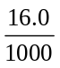dm³
= 0.032 mol

(b) From equation, 3 mol NaOH react with 1 mol H₃PO₄
So 0.032 mol NaOH react with 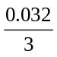 = 0.0107 mol H₃PO₄

(c) concentration of acid (mol/dm3) =
= 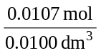
= 1.07 mol/dm³ — answer (a)

Molar mass of H₃PO₄ = 3 + 31 + 4×16 = 98 g/mol

So mass concentration = 1.07 mol/dm³ × 98 g/mol
= 105 g/dm³ — answer (b)

Preparing and Analysing Salts

Acids are neutralised by reacting them with either bases, alkalis, metals or carbonates to prepare crystalline examples of salts. The method adopted depends on the solubility of the reactants and the salt.

You need to know the general rules about solubility:
Soluble substances Insoluble substances
all common acids most metal oxides and hydroxides*
all Na⁺, K⁺ and NH₄⁺ compounds most metal carbonates*
most metal chlorides AgCl, PbCl₂
most metal sulphates PbSO₄, BaSO₄, CaSO₄ (slightly sol)
all metal nitrates
* except Na⁺, K⁺ and NH₄⁺

The difficulty in making salts is to obtain a pure sample of the salt, which is not contaminated by excess reactant.

(a) Acid + insoluble substance → SOLUBLE SALT + gas or water

The insoluble substance may be a reactive metal, a metal carbonate (not Na⁺ or K⁺), or a metal oxide (not Na⁺ or K⁺).
e.g. H₂SO₄(aq) + CuO(s) → CuSO₄(aq) + H₂O(l)

- A suitable volume of acid (e.g. about 40 cm³, not measured exactly) is placed in a beaker.
- Small amounts of the insoluble solid are added, stirring and warming if necessary, until some remains (i.e. no more can react – this is called an excess of solid).
- The solution is then filtered to remove the solid, and crystallised by heating in an evaporating basin until half the water has evaporated, then leaving to cool.

(b) Acid + soluble substance → SOLUBLE SALT + gas or water

The soluble substance may be a soluble carbonate (sodium, potassium or ammonium), or an alkali (NaOH, KOH or ammonia solution).
e.g. H₂SO₄(aq) + 2NaOH(aq) → Na₂SO₄(aq) + 2H₂O(l)

- Titration is used. 25 cm³of acid is placed in a conical flask, using a pipette.
- Indicator is added (e.g. methyl orange).
- Then the solution of alkali is added slowly from a burette (a graduated tube fitted with a tap at the bottom).
- The total volume (V cm³) of alkali needed to change the colour of the indicator is noted.
- A fresh 25 cm³ sample of acid is measured out, and V cm³ of alkali is added, without any indicator.
- The solution is now neutral and can be crystallised as before.
(c) metal nitrate + sodium salt → INSOLUBLE SALT + sodium nitrate

The principle here is that two solutions are mixed to form the insoluble substance. Since all nitrates and all sodium compounds are soluble, the salts suggested will always be suitable, but others could be used (e.g. any soluble silver salt, and any soluble chloride).
e.g. AgNO₃(aq) + NaCl(aq) → AgCl(s) + NaNO₃(aq)

- The two solutions are mixed, then boiled to help coagulate the precipitate.
- It is filtered hot, and the residue rinsed on the paper with distilled water.
- The paper is then spread out to dry.

We can write an ionic equation by just including the aqueous ions which form the precipitate here: Ag⁺(aq) + Cl–(aq) → AgCl(s)

Other examples:
Barium sulphate: from barium nitrate and sodium sulphate solutions
ionic equation: Ba²⁺(aq) + SO₄^{2–}(aq) → BaSO₄(s)

Calcium carbonate: from calcium nitrate and sodium carbonate solutions
ionic equation: Ca²⁺(aq) + CO₃^{2–}(aq) → CaCO₃(s)

Analysing Salts

Tests for Cations (positively charged ions).

Flame Tests - identify some metals ions by the characteristic colour emitted on heating their compounds in a Bunsen flame.
- A small sample of the compound is placed on a watch glass with a few drops of concentrated hydrochloric acid.
- A little of the resulting paste is then applied to the clean platinum or nichrome wire, and the colour is noted when the wire is heated in a non-luminous bunsen flame.

The table below lists some common metals that give characteristic flame colours:
Metal ion | Flame colour
K⁺ | lilac (mauve)
Na⁺ | yellow
Li⁺ | red
Ca²⁺ | brick red

The second test for the presence of positive ions (cations) in compounds uses a precipitation reaction with sodium hydroxide or ammonia.

The four tests which you need to know are;
Ion | Colour of solution | Adding NaOH solution
Cu²⁺ | blue or green. | light blue ppt. of Cu(OH)₂, insoluble in excess
Fe²⁺ | pale green | dirty green ppt. of Fe(OH)₂, insoluble in excess
Fe³⁺ | red/orange | red/brown ppt. of Fe(OH)₃, insoluble in excess
NH₄⁺ | colourless | no visible change; ammonia gas given on warming (recognisable smell, turns red litmus blue)

Note
- If no precipitate is formed, the metal ion is either sodium or potassium. These can be distinguished using a flame test.
- Ammonium ions also do not give a precipitate with sodium hydroxide. If a flame test on the solid shows no colour and there is no precipitate with sodium hydroxide solution then the positive ion is probably ammonium NH₄⁺.
- If the solution is heated, ammonia gas will be produced.

Equations for cation tests

The reactions below are shown with the metal chloride but any soluble compound could be used. The ionic equation is also given.
copper(II) chloride + sodium hydroxide → copper(II) hydroxide + sodium chloride
CuCl_{2(aq)} + 2NaOH_{(aq)} → Cu(OH)_{2(s)} + 2NaCl_{(aq)}

The ionic equation is Cu²⁺_{(aq)} + 2OH⁻_{(aq)} → Cu(OH)_{2(s)}
Copper(II) hydroxide is blue.

iron(III) chloride + sodium hydroxide → iron(III) hydroxide + sodium chloride
FeCl_{3(aq)} + 3NaOH_{(aq)} → Fe(OH)_{3(s)} + 3NaCl_{(aq)}

The ionic equation is Fe³⁺_{(aq)} + 3OH⁻_{(aq)} → Fe(OH)_{3(s)}
Iron(III) hydroxide is brown.

Testing for transition metal ions

ION | Colour | Addition of NaOH_{(aq)} | Excess NaOH_{(aq)} | Addition of NH_{3(aq)} | Excess NH_{3(aq)}
Fe²⁺ | Pale green | Dirty green ppte → turns brown as oxidised by air to Fe(OH)₃ | Ppte remains | Dirty green ppte | Ppte remains
Fe³⁺ | Yellow/brown | Brown-red | Ppte remains | Brown-red | Ppte remains
Cu²⁺ | Pale blue | Blue ppte | Ppte remains | Pale blue ppte | Deep blue solution

Tests for Common gases
gas | test | result
H₂ | lighted splint | Burns with squeaky pop
O₂ | glowing splint | Relights
CO₂ | bubble through limewater | limewater turns milky
NH₃ | smell  damp litmus  Conc HCl at mouth of bottle | pungent  red litmus turns blue  white smoke forms
Cl₂ | smell  damp litmus | swimming pool smell  blue litmus turns red then is bleached

Tests for Anions

The negative ions (anions) have specific tests as described below. In the tests for chloride, bromide, iodide and sulphate the chemical principle is that when two ions which form an insoluble substance are brought together they will form a precipitate.

Chloride, bromide and iodide tests (Cl–, Br–, and I–)
- Dissolve some of the substance in distilled water.
- Add a little dilute nitric acid, and then some silver nitrate solution.

If substance is a chloride, a white precipitate of silver chloride is formed.
e.g. MgCl₂(aq) + 2AgNO₃(aq) → Mg(NO₃)₂(aq) + 2AgCl(s)

Ionic equation: Ag⁺(aq) + Cl–(aq) → AgCl(s)

If substance is a bromide, a cream precipitate of silver bromide, AgBr, is formed.

If substance is an iodide, a pale yellow precipitate of silver iodide, AgI, is formed.

- To help distinguish the colours, the AgCl precipitate will dissolve if shaken with excess dilute ammonia solution.
- The AgBr precipitate will only dissolve in concentrated ammonia solution.
- AgI is not soluble even in concentrated ammonia.

Sulphate test (SO₄^{2–})
- Dissolve some of the substance in distilled water.
- Add a little dilute hydrochloric acid and then barium chloride solution.

If substance is a sulphate, a white precipitate of barium sulphate is formed.

e.g. BaCl₂(aq) + Na₂SO₄(aq) → BaSO₄(s) + 2NaCl(aq)

Ionic equation: Ba²⁺(aq) + SO₄^{2–}(aq) → BaSO₄(s)

Carbonate test (CO₃^{2–})
- Add some dilute nitric acid to solid substance in a test tube.

If substance is a carbonate, it will fizz immediately, and give off a gas which turns limewater milky. Acid + a solution of a carbonate will also work, fizzing in the cold, but few carbonates are soluble.

e.g. CuCO₃(s) + 2HNO₃(aq) → Cu(NO₃)₂ + H₂O(l) + CO₂(g)

Rates of Reaction
The main factors which affect how fast a reaction goes are;
- the concentration of the reactants (or pressure if they are gases)
- the temperature of the reaction mixture
- the surface area of any solid reactants, or solid catalyst
- the presence of a catalyst.

To explain how these factors affect rate we use collision theory.
Molecules and ions need to collide before they can react.

e.g. The reaction between marble chips (calcium carbonate) and hydrochloric acid.
CaCO₃(s) + 2HCl(aq) → CaCl₂(aq) + H₂O(l) + CO₂(g)
The acid gives hydrogen ions, H+(aq), and it is these which collide with the marble chips.

(i) Concentration: this means the amount of substance dissolved in a given volume..
If we double the concentration of acid, there will be twice as many hydrogen ions in a given volume, and so twice as many collisions with marble each second.
Although every collision does not lead to reaction, doubling the total number of collisions should double the rate of reaction.
Note that if we add a larger volume of acid of the same concentration, the rate will be the same at first, but reaction will carry on for longer, and more gas will be produced at the end. An experiment to show this might use one large chip of limestone, and the same volume of acid but of different concentrations.
A graph of rate against concentration of acid should be a straight line, going through the origin (line (a) in the diagram below). For gaseous reactants, the pressure is the most convenient measure of concentration.
Concentration
Rate
(a)
(b)
Rate

Temperature

(ii) Temperature: when we heat a reaction mixture up, the rate of reaction rises sharply (curve (b) above).
For many reactions the rate will double if the temperature rises by 10ºC, and then double again for the next 10o rise.
The minimum energy which molecules must gain before they can react is called the activation energy.
When a reaction mixture is heated up, the molecules move around more rapidly, and far more of them have enough energy to react (the activation energy). There is also a small increase in the number of collisions. Both factors mean that there are more successful collisions, in a given time, which lead to reaction, so the rate increases sharply.

(iii) Surface Area: if a reaction involves a solid, it can only occur when molecules strike the surface. Therefore if there is a larger surface area, more particles will be exposed and so there will be more collisions, per second, and the rate will be faster.
In general: rate with large lumps is less than rate with small lumps is less than rate with powder.

If you are designing an experiment to show this, you must be careful to use the same mass of solid, the same temperature, and the same volume of acid. There should be an excess of solid, so most of it doesn’t get used up. The diagram below applies to a flask containing marble chips and acid on a balance: results like curve (c) might be obtained with large chips, and curve (d) with small chips.

(c)
(d)
Time

(iv) Catalysts: a catalyst is a substance which, when added in small amount, will speed up a chemical reaction, without itself being used up.
Catalysts provide an alternative route for the reaction that has a lower activation energy. Therefore more particles have the minimum energy to react and so more of the collisions are successful.
There is no catalyst for the reaction between marble chips and hydrochloric acid. However, many other reactions are speeded up by catalysts. Different reactions need different catalysts.

Examples of catalysis:
• decomposition of hydrogen peroxide by manganese(IV) oxide
2H₂O₂ → 2H₂O + O₂ [MnO₂ as catalyst]
• the Haber Process for manufacture of ammonia
N₂ + 3H₂ 2NH₃ [finely divided iron as catalyst]
• the Contact Process for manufacture of sulphuric acid
2SO₂ + O₂ 2SO₃ [Vanadium(V) oxide as catalyst]

A solid catalyst works by allowing reactants to bind temporarily to its surface. This can weaken their chemical bonds (providing an alternative route with lower activation energy), and/or bring them together so that they can react. Once reaction is complete the products leave the surface, which can act as catalyst for more reactants.
Equilibria

Reversible Reactions
Some chemical reactions are reversible. This is shown in a reaction equation using a sign.

e.g. CuSO₄.5H₂O_{(s)} CuSO_{4(s)} + 5H₂O_{(l)}
Hydrated copper sulphate Anhydrous copper sulphate

If hydrated copper sulphate is heated it thermally decomposes into anhydrous copper sulphate and water.
If water is added to anhydrous copper sulphate it turns into hydrated copper sulphate.

A reversible reaction is one in which the same position of equilibrium can be reached by starting with suitable amounts of reactants (on the left) or products (on the right).

Equilibrium
At equilibrium reactants and products are both present, and their concentrations are constant.

In a reversible reaction, if the reactants are mixed, their concentrations will fall, rapidly at first, but then more and more slowly, until they settle to their “equilibrium” values. Meanwhile the amounts of products will increase, until they too achieve their equilibrium amounts. The actual values of these amounts depend on the conditions.
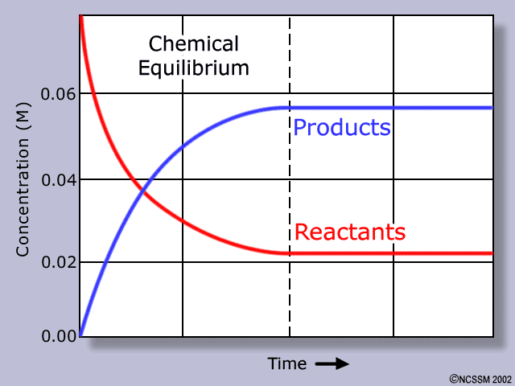
When equilibrium is reached, the reaction has not stopped: instead, the rate at which the forward reaction is proceeding is exactly balanced by the rate of the reverse reaction
If the position of equilibrium lies to the left, the concentrations of reactants (the left-hand side of the equation) are higher.
If the position lies to the right, there will be more of the products.

Changing the position of an equilibrium
Le Chatelier's Principle can be stated in several ways.
One version is: “If a system is at equilibrium and one of the conditions is changed, the position of equilibrium will alter in the direction which tends to minimise the effect of the change.”

Examples of this are:
Adding a reactant: the amounts of products will have increased, and the increase in concentration of the reactant will be less than expected, because some of the additional amount has been used up.

Increasing the temperature: this causes the equilibrium to shift in the direction of absorption of heat (the endothermic direction). In effect, it takes more heat energy to bring about a given temperature rise, because some of the heat energy is absorbed in changing the position of equilibrium, giving more of the side with the higher enthalpy content.
Decreasing the temperature causes the reaction to shift in the exothermic direction.

Increasing the pressure: this causes the position of equilibrium to shift towards the side which has the smaller number of gas molecules. If the number of gas molecules on each side is the same [e.g. CO(g) + H₂O(g) CO₂(g) + H₂(g) ] pressure has no effect.

Adding a catalyst: this speeds up forward and reverse reactions equally, and so it has no effect on the position of equilibrium, but allows equilibrium to be reached more quickly.

Industrial Process 1 - The Haber process

There is a large demand for nitrogen compounds, for making fertilisers and explosives, but there are no large-scale minerals containing nitrogen compounds. Therefore nitrogen compounds have to be made from nitrogen gas, obtained from the atmosphere. N2 is very unreactive because it contains a very strong triple bond, N≅N, and the only suitable reaction to make nitrogen compounds from it, is that with hydrogen (the Haber process).
N₂(g) + 3H₂(g) 2NH₃(g)

Raw materials for the process
- Nitrogen is obtained from air, by burning methane, to remove oxygen.

- Hydrogen is obtained either by cracking alkanes from oil:
e.g. C₂H₆(g) → C₂H₄(g) + H₂(g)

or by reaction between methane and steam over a nickel catalyst:
CH₄(g) + H₂O CO(g) + 3H₂(g)

Obtaining the optimum yield from the process
Using a 1:3 ratio of nitrogen to hydrogen, the percentage yield of ammonia under different conditions is given by the table:

Pressure/atm | 300ºC | 400ºC | 500ºC | 600ºC | 700ºC
1 | 2.2% | 0.4% | 0.1% | 0.05% | 0.02%
10 | 14.7 | 3.9 | 1.2 | 0.5 | 0.2
30 | 31.8 | 10.7 | 3.6 | 1.4 | 0.7
100 | 51.2 | 25.1 | 10.4 | 4.5 | 2.1
200 | 62.8 | 36.3 | 17.6 | 8.2 | 4.1
1000 | 92.6 | 79.8 | 57.5 | 31.4 | 12.9
You will be expected to be able to interpret data tables like this.

Here it is clear that increasing pressure at any one temperature will increase the yield, while at any given pressure increasing the temperature decreases the yield.

Ideal conditions would be high pressure and low temperature.
- Increasing the pressure costs more, and also means a stronger reaction vessel, which is more expensive: typically 200 atm is used.
- While a low temperature is desirable, the rate of reaction is too low. Even with the best catalysts, a temperature of 450oC must be used.

Choice of conditions in industrial reactions depends on minimising costs, and is always a compromise. For example, it may be cheaper to obtain a 60% yield rapidly, than a 99% yield slowly, especially if unreacted gases can be recycled and used again. Sometimes a company will choose a more expensive plant which has lower running costs: whether this is a good idea depends on predicting how interest rates, labour costs and raw material costs will vary over a period of 15-20 years.

Haber Process summary N₂(g) + 3H₂(g) 2NH₃(g)

Conditions used : 200 atmospheres pressure, 450ºC, catalyst of finely divided iron.

The ammonia produced is liquefied by cooling and increasing the pressure, and unreacted nitrogen and hydrogen are recycled.

Note that the use of an iron catalyst speeds up the reaction equally in both directions: it therefore increases the rate but does not affect the yield.

Uses of ammonia
Ammonia is an alkaline gas, and by neutralising sulphuric or nitric acids it can be converted into ammonium sulphate, (NH₄)₂SO₄, and ammonium nitrate, NH₄NO₃:
2NH₃ + H₂SO₄ → (NH₄)₂SO₄
used as fertilisers
NH₃ + HNO₃ → NH₄NO₃

Ammonia is converted to nitric acid by oxidising the ammonia.
Nitric acid is the starting point for making ammonium nitrate, as well as manufacture of explosives and dyes.
Fertilisers
When crops are grown repeatedly on the same soil, compounds containing the elements nitrogen, phosphorus and potassium (N, P and K) are removed from the soil. A large increase in yield is obtained if fertilisers containing these elements are added to the soil, and it is nitrogenous fertilisers which have the greatest effect.

Almost any soluble nitrogen compound may be added as a fertiliser. The commonest ones used are ammonium nitrate, NH₄NO₃ (N in both NH₄⁺ and NO₃– can be used), ammonium sulphate, (NH₄)₂SO₄, and urea, CO(NH₂)₂.

Industrial Process 2 - The Contact process

Sulphuric acid is produced from Sulphur industrially by a three stage process:

Stage 1 - Sulphur is burnt in air to form sulphur dioxide.
S + O₂ → SO₂

Stage 2 - The Contact Process is the main reaction, in which sulphur dioxide is catalytically oxidised to sulphur trioxide by mixing it with air and passing the mixture over a vanadium(V) oxide catalyst at 450oC.
2SO₂(g) + O₂(g) 2SO₃(g)

As soon as some sulphur trioxide is formed it starts to decompose back to sulphur dioxide and oxygen. As more sulphur trioxide is produced the rate at which it decomposes increases, until there is a balance or equilibrium. At equilibrium the rate of the forward reaction (left-to-right) is equal to the rate of the reverse reaction (right-to-left).

One way of increasing the yield of products is to remove them as they are formed. This will prevent products reacting back to form reactants, and so it will displace the equilibrium to the right, leading to a higher percentage conversion of the reactants.

Another way of shifting the equilibrium is by changing the pressure (if gases are involved). If the pressure is increased the equilibrium moves to the side with the smaller number of moles of gas. This is the case for the contact process and so the process is carried out at 2 atmospheres of pressure. Although higher pressures would increase the yield further they is would be more expensive.

The forward reaction is exothermic (gives out heat), so a low temperature increases the yield, but it must be hot enough to achieve a reasonable rate of reaction.

Stage 3 - The sulphur trioxide is then passed into 98% sulphuric acid, producing an even more concentrated acid which is then diluted down. The overall reaction is simply SO3 reacting with the 2% water to form sulphuric acid. The reason for performing this reaction in concentrated sulphuric acid is to prevent the formation of a hazardous fog of acid droplets.
SO₃ + H₂O → H₂SO₄

Properties of Sulphuric Acid
Pure sulphuric acid is a viscous, dense liquid with a high boiling point (330oC).

Reactions:
(a) With water. The acid reacts to form ions, liberating much heat. Therefore, when diluting sulphuric acid one should always add the acid to water (splashes are dilute), not the other way round:
H₂SO₂4(l) + H₂O(l) → H₃O+(aq) + HSO₄–(aq)

Sulphuric acid is often used as a drying agent to dry gases (but it cannot be used for ammonia, since it reacts with it to form ammonium sulphate).

(b) As a dehydrating agent. The affinity for water means that sulphuric acid can decompose chemical compounds by removing water (or the components of water).

Hydrated copper(II) sulphate crystals turn from blue to white, when left to stand in concentrated sulphuric acid:
CuSO₄ .5H₂O → 5H₂O + CuSO₄
blue white

Sucrose (sugar) turns slowly brown then black in an excess of acid:
C₁₂H₂₂O₁₁ → 11H₂O + 12C

Uses of Sulphuric acid

Making ammonium sulphate, for use as a fertiliser. NH₃ + H₂SO₄ → (NH₄)₂SO₄

Making detergents, paint pigments, and explosives.

